[](http://www.comsol.com/)

liquid cooling

|  |  |
| --- | --- |
| Report date | Apr 29, 2025 10:58:24 AM |

Contents

1. Global Definitions

2. Component 1

2.1. Definitions

2.2. Geometry 1

2.3. Materials

2.4. Heat Transfer in Solids

2.5. Laminar Flow

2.6. Mesh 1

3. Study 1

3.1. Time Dependent

3.2. Stationary

3.3. Solver Configurations

4. Results

4.1. Data Sets

4.2. Derived Values

4.3. Tables

4.4. Plot Groups

1. Global Definitions

|  |  |
| --- | --- |
| Date | Apr 28, 2025 1:02:22 PM |

Global settings

|  |  |
| --- | --- |
| Name | Untitliquid cooling.mph |
| Path | C:\Users\Harshita Agrawal\Desktop\Untitliquid cooling.mph |
| Version | COMSOL Multiphysics 5.4 (Build: 388) |
| Unit system | SI |

Used products

|  |
| --- |
| COMSOL Multiphysics |

1. Component 1

|  |  |
| --- | --- |
| Date | Apr 28, 2025 11:03:29 AM |

Settings

| **Description** | **Value** |
| --- | --- |
| Unit system | Same as global system |
| Geometry shape order | Automatic |

Spatial frame coordinates

| **First** | **Second** | **Third** |
| --- | --- | --- |
| x | y | z |

Material frame coordinates

| **First** | **Second** | **Third** |
| --- | --- | --- |
| X | Y | Z |

Geometry frame coordinates

| **First** | **Second** | **Third** |
| --- | --- | --- |
| Xg | Yg | Zg |

Mesh frame coordinates

| **First** | **Second** | **Third** |
| --- | --- | --- |
| Xm | Ym | Zm |

* 1. Definitions
     1. Component Couplings

#### Average 1

|  |  |
| --- | --- |
| Coupling type | Average |
| Operator name | aveop1 |

Selection

|  |  |
| --- | --- |
| Geometric entity level | Domain |
| Selection | Domain 1 |

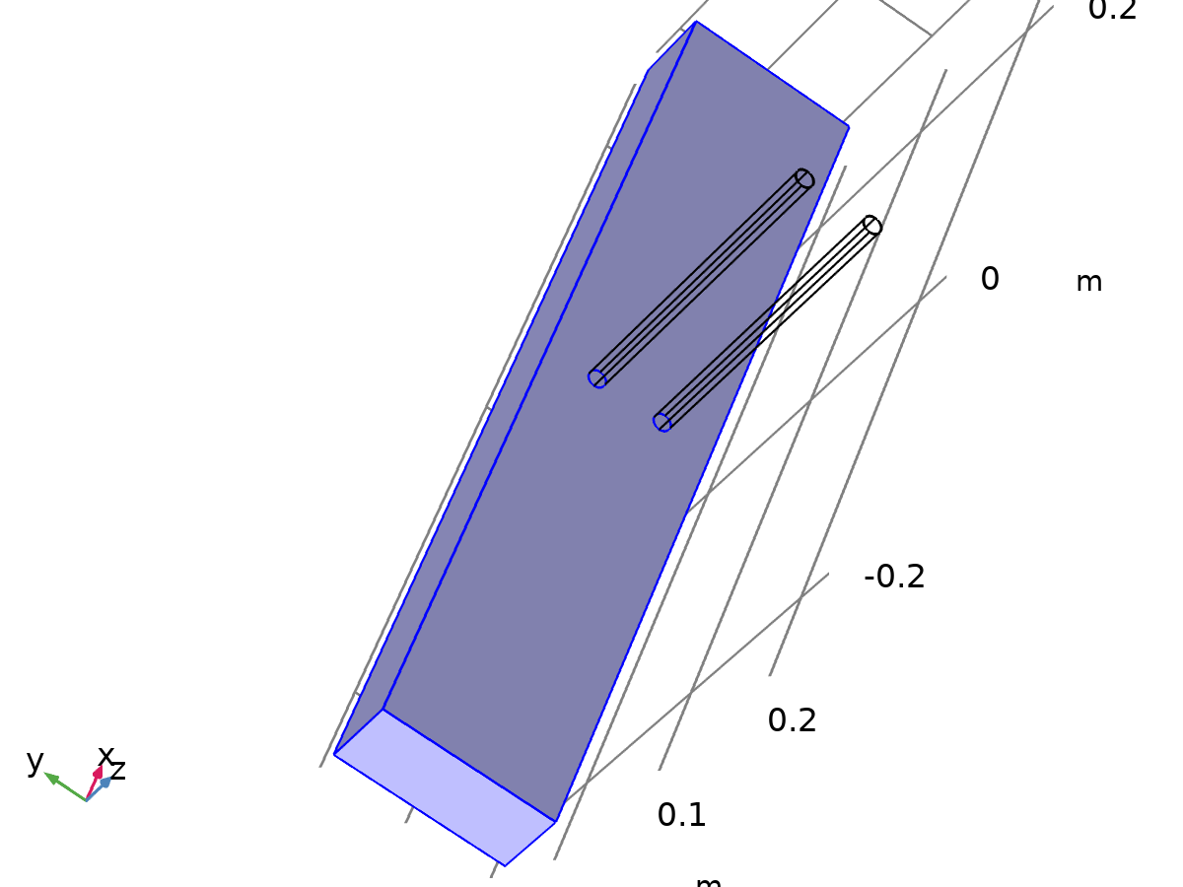

Selection

* + 1. Coordinate Systems

#### Boundary System 1

|  |  |
| --- | --- |
| Coordinate system type | Boundary system |
| Tag | sys1 |

Coordinate names

| **First** | **Second** | **Third** |
| --- | --- | --- |
| t1 | t2 | n |

* 1. Geometry 1

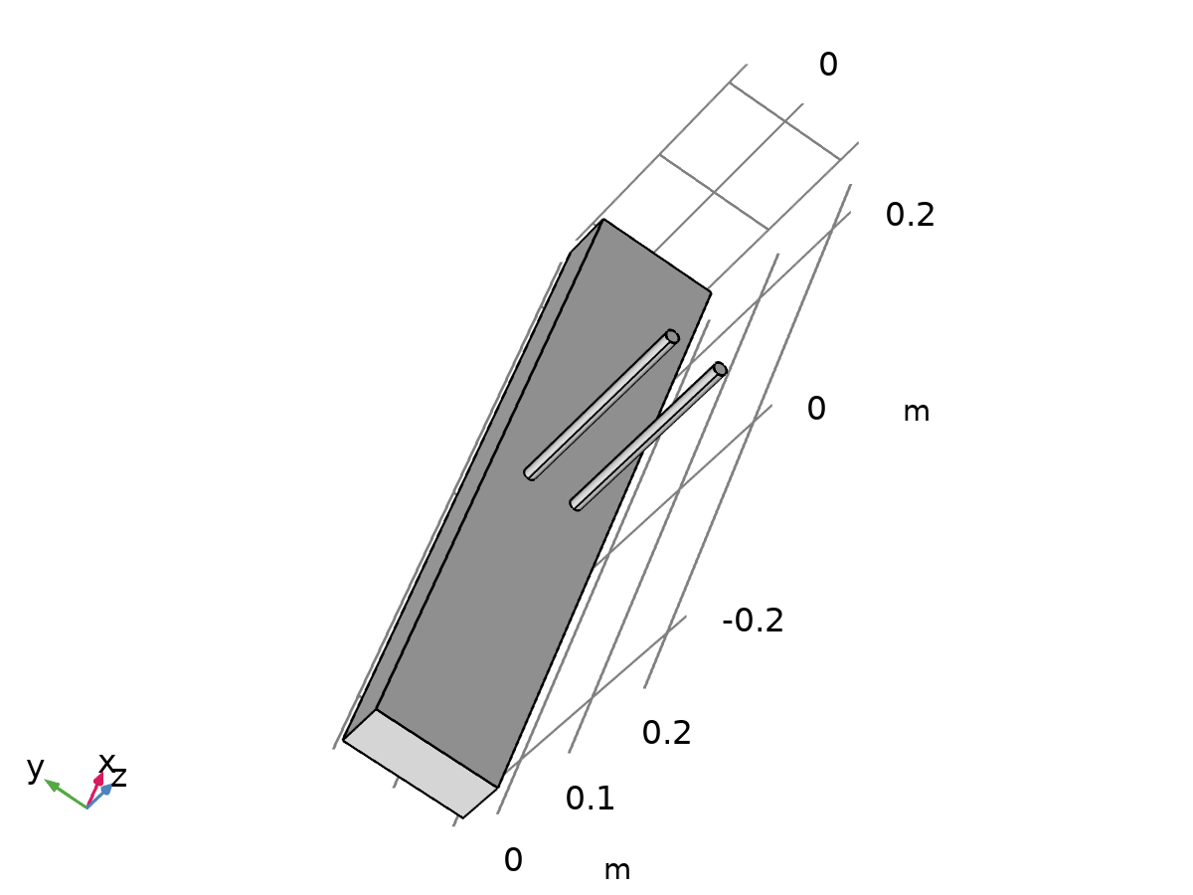

Geometry 1

Units

|  |  |
| --- | --- |
| Length unit | m |
| Angular unit | deg |

Geometry statistics

| **Description** | **Value** |
| --- | --- |
| Space dimension | 3 |
| Number of domains | 3 |
| Number of boundaries | 18 |
| Number of edges | 36 |
| Number of vertices | 24 |

* + 1. Block 1 (blk1)

Position

| **Description** | **Value** |
| --- | --- |
| Position | {0, 0, 0} |
| Base | Center |

Axis

| **Description** | **Value** |
| --- | --- |
| Axis type | z - axis |

Size and shape

| **Description** | **Value** |
| --- | --- |
| Width | 0.5 |
| Depth | 0.1 |
| Height | 0.05 |

* + 1. Cylinder 1 (cyl1)

Position

| **Description** | **Value** |
| --- | --- |
| Position | {0, 0.02, 0.025} |

Axis

| **Description** | **Value** |
| --- | --- |
| Axis type | z - axis |

Size and shape

| **Description** | **Value** |
| --- | --- |
| Radius | 0.005 |
| Height | 0.2 |

* + 1. Cylinder 2 (cyl2)

Position

| **Description** | **Value** |
| --- | --- |
| Position | {0, -0.02, 0.025} |

Axis

| **Description** | **Value** |
| --- | --- |
| Axis type | z - axis |

Size and shape

| **Description** | **Value** |
| --- | --- |
| Radius | 0.005 |
| Height | 0.2 |

* + 1. Cylinder 3 (cyl3)

Position

| **Description** | **Value** |
| --- | --- |
| Position | {0, 0.02, 0.025} |

Axis

| **Description** | **Value** |
| --- | --- |
| Axis type | z - axis |

Size and shape

| **Description** | **Value** |
| --- | --- |
| Radius | 0.005 |
| Height | 0.2 |

* + 1. Cylinder 4 (cyl4)

Position

| **Description** | **Value** |
| --- | --- |
| Position | {0, -0.02, 0.025} |

Axis

| **Description** | **Value** |
| --- | --- |
| Axis type | z - axis |

Size and shape

| **Description** | **Value** |
| --- | --- |
| Radius | 0.005 |
| Height | 0.2 |

* 1. Materials
     1. Battery Block



Battery Block

Selection

|  |  |
| --- | --- |
| Geometric entity level | Domain |
| Selection | Domain 1 |

Material parameters

| **Name** | **Value** | **Unit** |
| --- | --- | --- |
| Heat capacity at constant pressure | 1000 | J/(kg·K) |
| Density | 2500 | kg/m³ |
| Thermal conductivity | 1 | W/(m·K) |

Basic Settings

| **Description** | **Value** |
| --- | --- |
| Coefficient of thermal expansion | {{alpha_p(pA, T), 0, 0}, {0, alpha_p(pA, T), 0}, {0, 0, alpha_p(pA, T)}} |
| Mean molar mass | 0.02897 |
| Bulk viscosity | muB(T) |
| Relative permeability | {{1, 0, 0}, {0, 1, 0}, {0, 0, 1}} |
| Relative permittivity | {{1, 0, 0}, {0, 1, 0}, {0, 0, 1}} |
| Dynamic viscosity | eta(T) |
| Ratio of specific heats | 1.4 |
| Electrical conductivity | {{0[S/m], 0, 0}, {0, 0[S/m], 0}, {0, 0, 0[S/m]}} |
| Heat capacity at constant pressure | 1000 |
| Density | 2500 |
| Thermal conductivity | {{1, 0, 0}, {0, 1, 0}, {0, 0, 1}} |
| Speed of sound | cs(T) |

Functions

| **Function name** | **Type** |
| --- | --- |
| eta | Piecewise |
| Cp | Piecewise |
| rho | Analytic |
| k | Piecewise |
| cs | Analytic |
| alpha_p | Analytic |
| muB | Analytic |

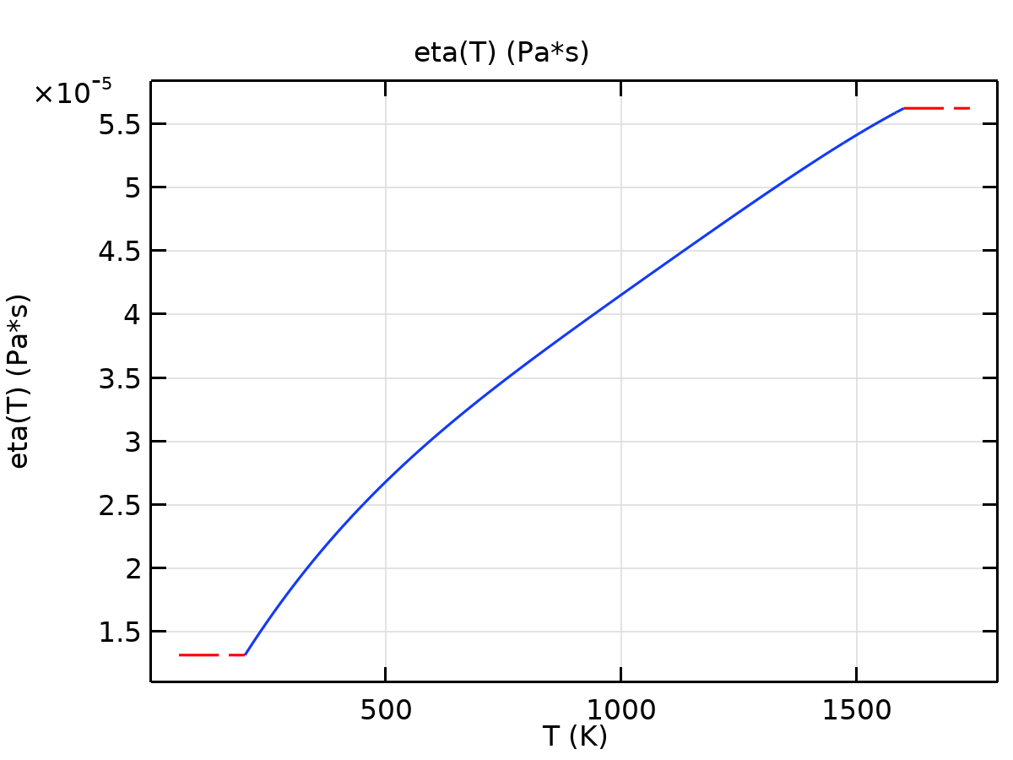

eta

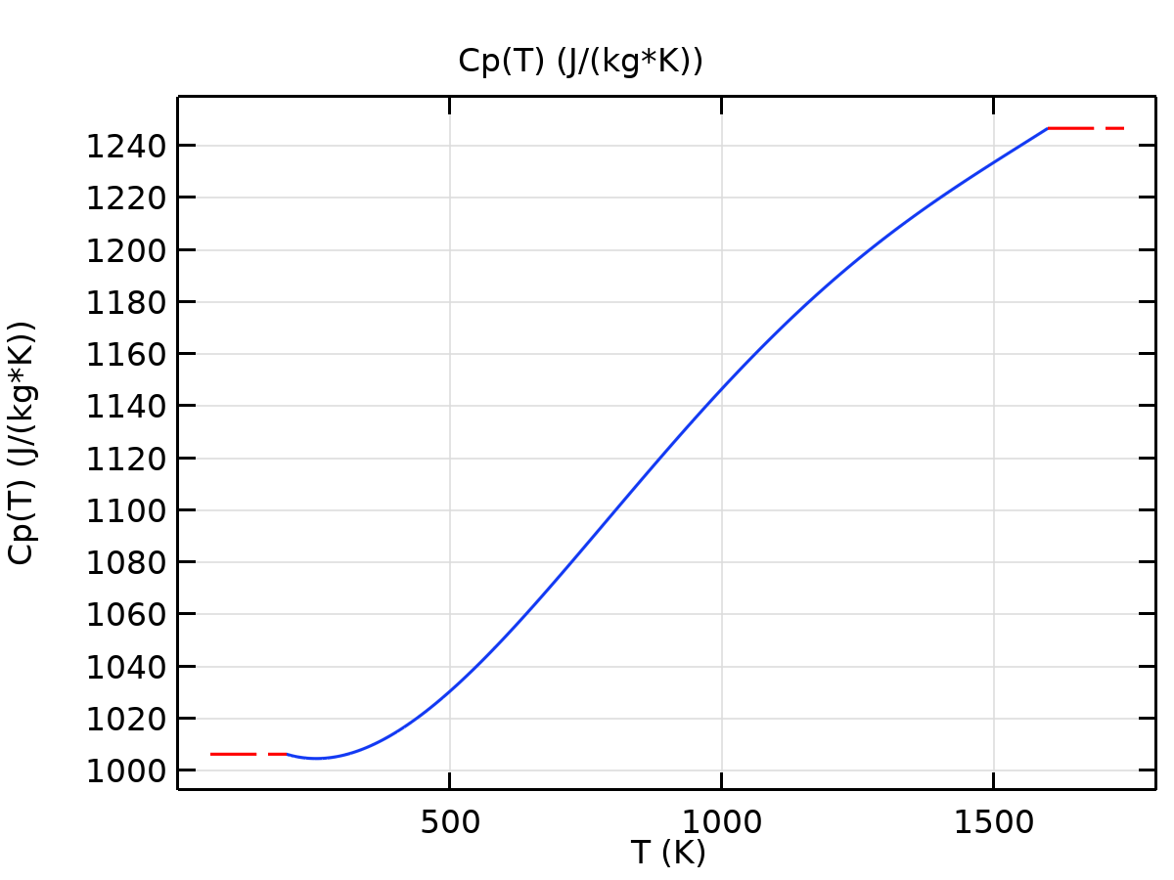

Cp

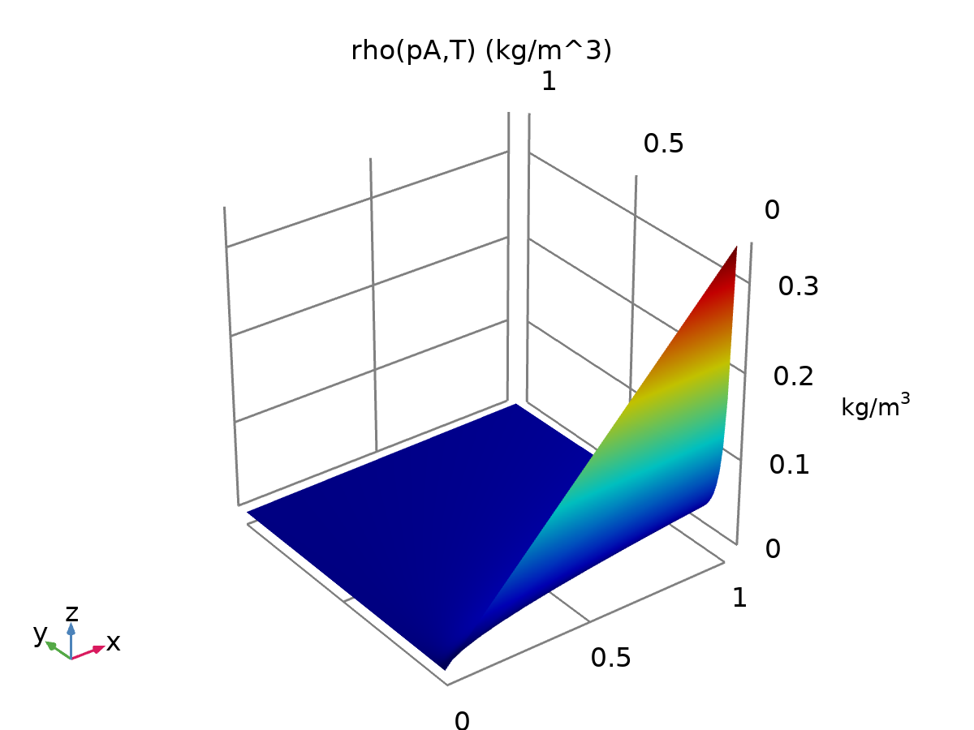

rho

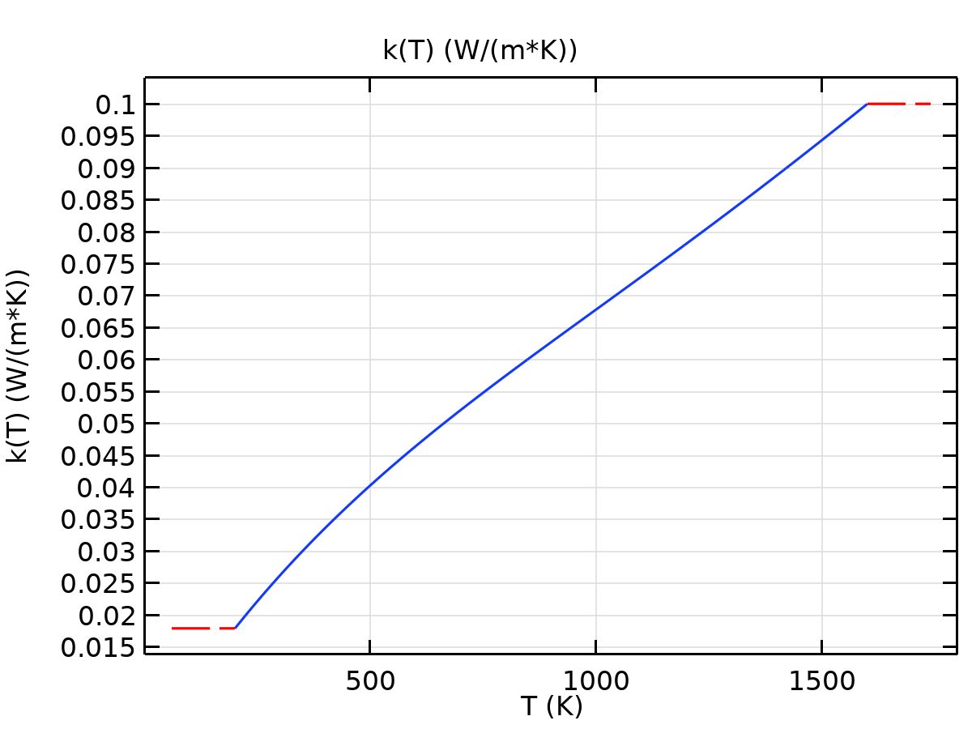

k

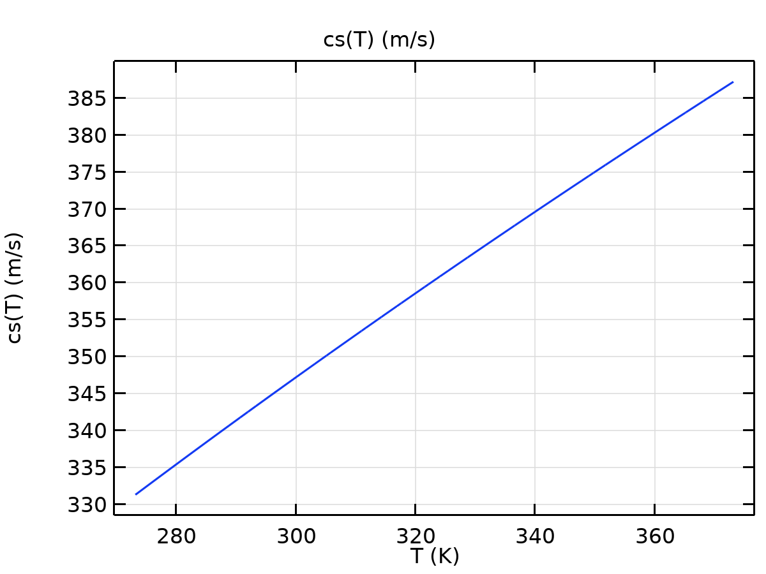

cs

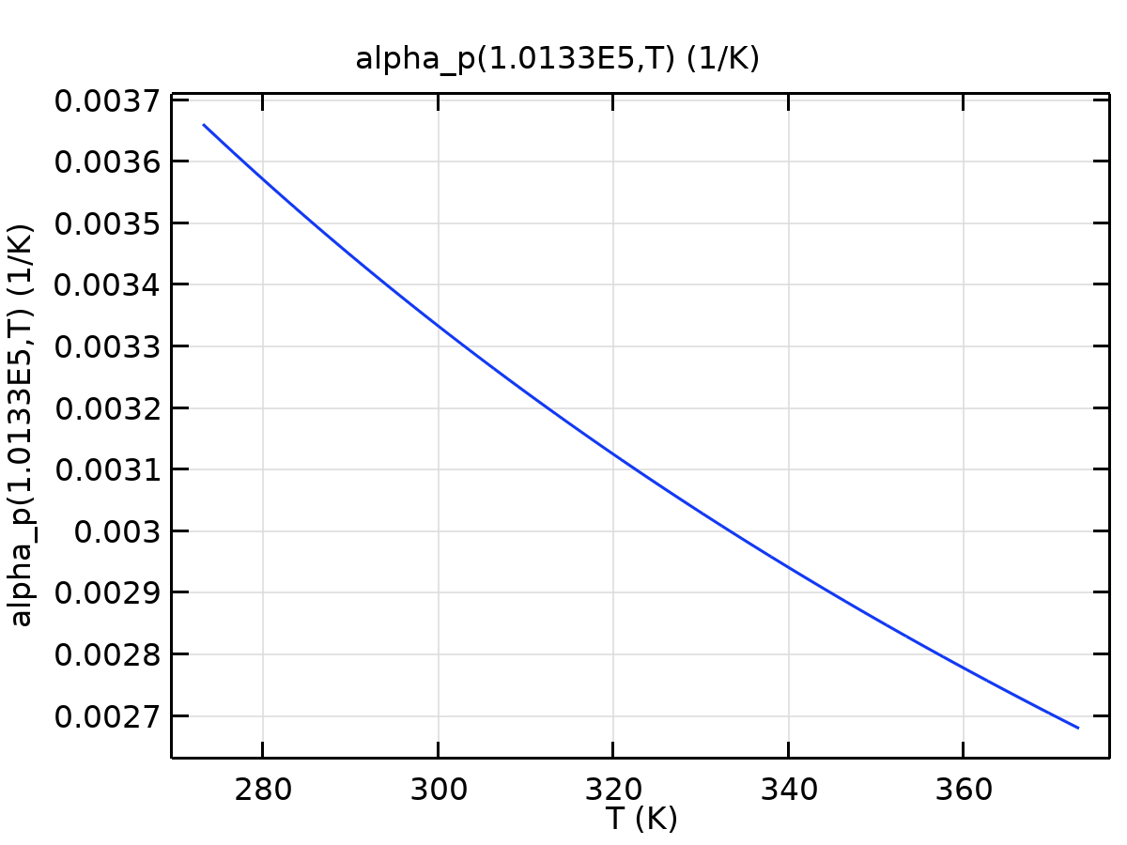

alpha_p

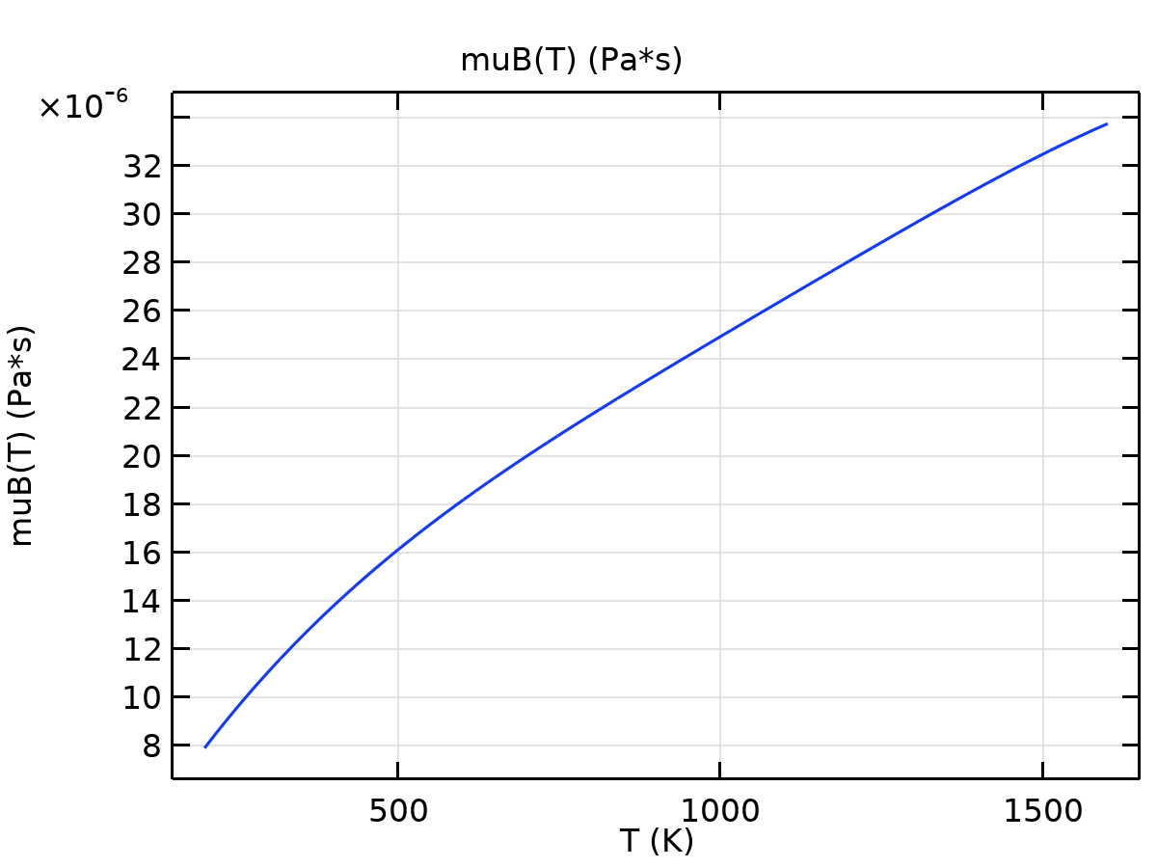

muB

Refractive index Settings

| **Description** | **Value** |
| --- | --- |
| Refractive index, real part | {{1, 0, 0}, {0, 1, 0}, {0, 0, 1}} |
| Refractive index, imaginary part | {{0, 0, 0}, {0, 0, 0}, {0, 0, 0}} |

Nonlinear model Settings

| **Description** | **Value** |
| --- | --- |
| Parameter of nonlinearity | (def.gamma + 1)/2 |

* + 1. Air

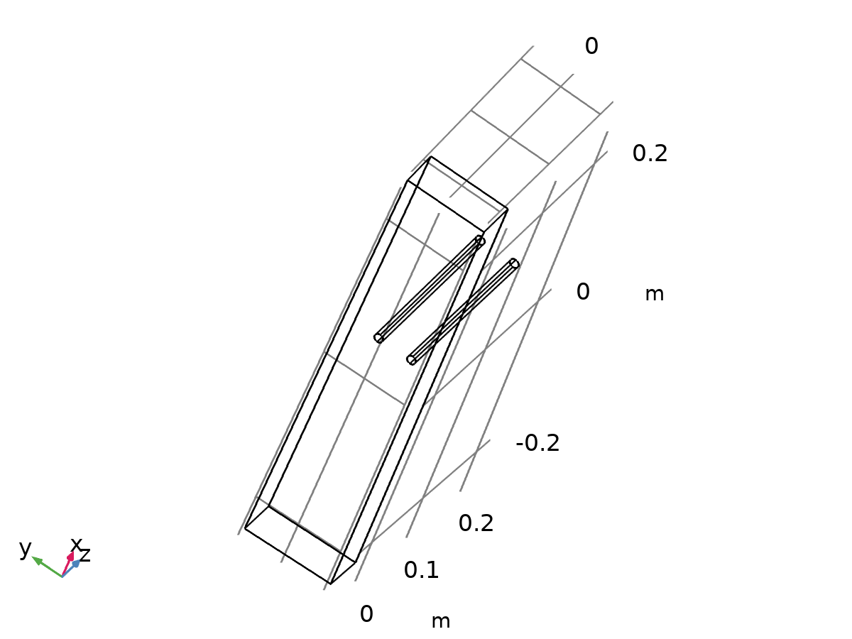

Air

Selection

|  |  |
| --- | --- |
| Geometric entity level | Domain |
| Selection | No domains |

Basic Settings

| **Description** | **Value** |
| --- | --- |
| Coefficient of thermal expansion | {{alpha_p(pA, T), 0, 0}, {0, alpha_p(pA, T), 0}, {0, 0, alpha_p(pA, T)}} |
| Mean molar mass | 0.02897 |
| Bulk viscosity | muB(T) |
| Relative permeability | {{1, 0, 0}, {0, 1, 0}, {0, 0, 1}} |
| Relative permittivity | {{1, 0, 0}, {0, 1, 0}, {0, 0, 1}} |
| Dynamic viscosity | eta(T) |
| Ratio of specific heats | 1.4 |
| Electrical conductivity | {{0[S/m], 0, 0}, {0, 0[S/m], 0}, {0, 0, 0[S/m]}} |
| Heat capacity at constant pressure | 4180 |
| Density | 1050 |
| Thermal conductivity | {{0.6, 0, 0}, {0, 0.6, 0}, {0, 0, 0.6}} |
| Speed of sound | cs(T) |

Functions

| **Function name** | **Type** |
| --- | --- |
| eta | Piecewise |
| Cp | Piecewise |
| rho | Analytic |
| k | Piecewise |
| cs | Analytic |
| alpha_p | Analytic |
| muB | Analytic |



eta



Cp



rho



k



cs



alpha_p



muB

Refractive index Settings

| **Description** | **Value** |
| --- | --- |
| Refractive index, real part | {{1, 0, 0}, {0, 1, 0}, {0, 0, 1}} |
| Refractive index, imaginary part | {{0, 0, 0}, {0, 0, 0}, {0, 0, 0}} |

Nonlinear model Settings

| **Description** | **Value** |
| --- | --- |
| Parameter of nonlinearity | (def.gamma + 1)/2 |

* + 1. Water, liquid

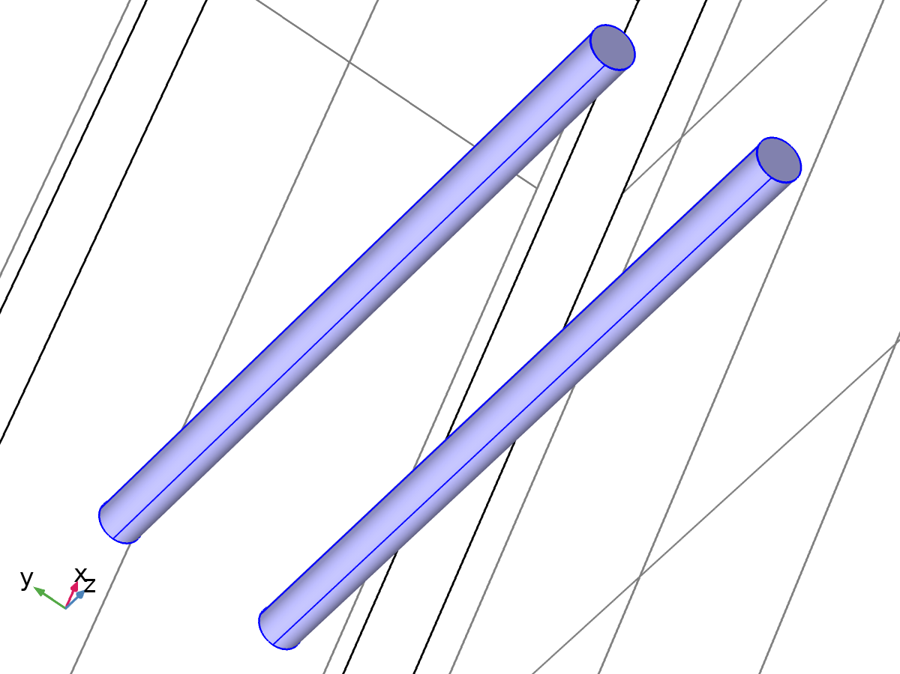

Water, liquid

Selection

|  |  |
| --- | --- |
| Geometric entity level | Domain |
| Selection | Domains 2–3 |

Material parameters

| **Name** | **Value** | **Unit** |
| --- | --- | --- |
| Dynamic viscosity | eta(T) | Pa·s |
| Density | rho(T) | kg/m³ |

Basic Settings

| **Description** | **Value** |
| --- | --- |
| Coefficient of thermal expansion | {{alpha_p(T), 0, 0}, {0, alpha_p(T), 0}, {0, 0, alpha_p(T)}} |
| Bulk viscosity | muB(T) |
| Dynamic viscosity | eta(T) |
| Ratio of specific heats | gamma_w(T) |
| Electrical conductivity | {{5.5e-6[S/m], 0, 0}, {0, 5.5e-6[S/m], 0}, {0, 0, 5.5e-6[S/m]}} |
| Heat capacity at constant pressure | Cp(T) |
| Density | rho(T) |
| Thermal conductivity | {{k(T), 0, 0}, {0, k(T), 0}, {0, 0, k(T)}} |
| Speed of sound | cs(T) |

Functions

| **Function name** | **Type** |
| --- | --- |
| eta | Piecewise |
| Cp | Piecewise |
| rho | Piecewise |
| k | Piecewise |
| cs | Interpolation |
| alpha_p | Analytic |
| gamma_w | Analytic |
| muB | Analytic |

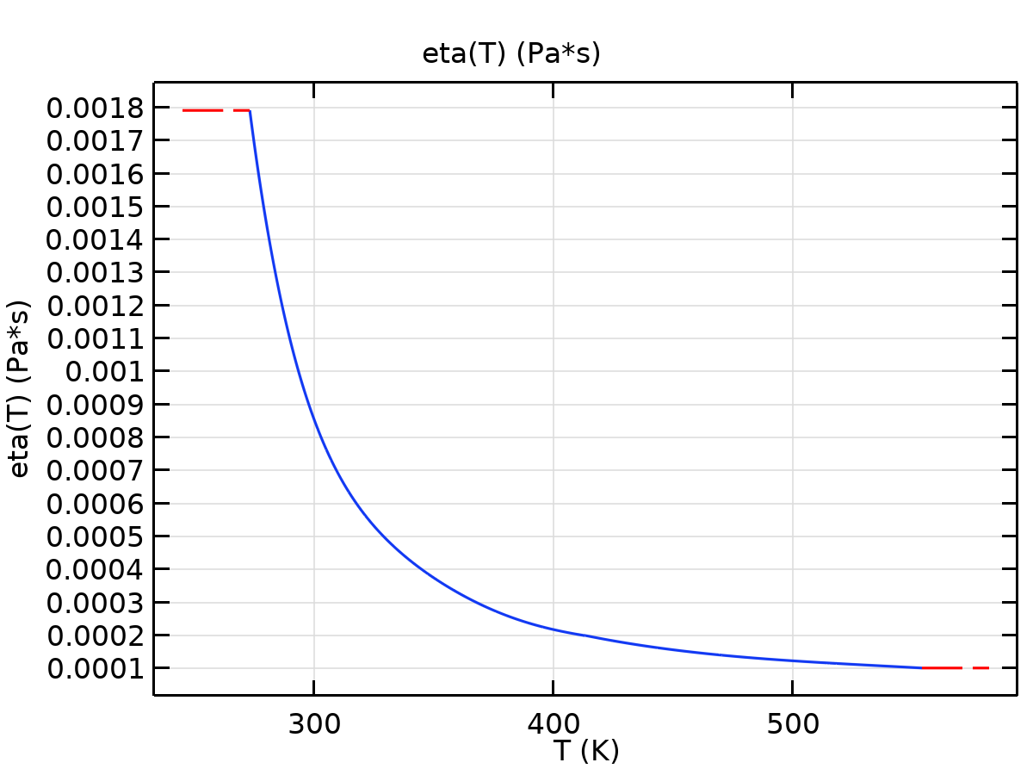

eta

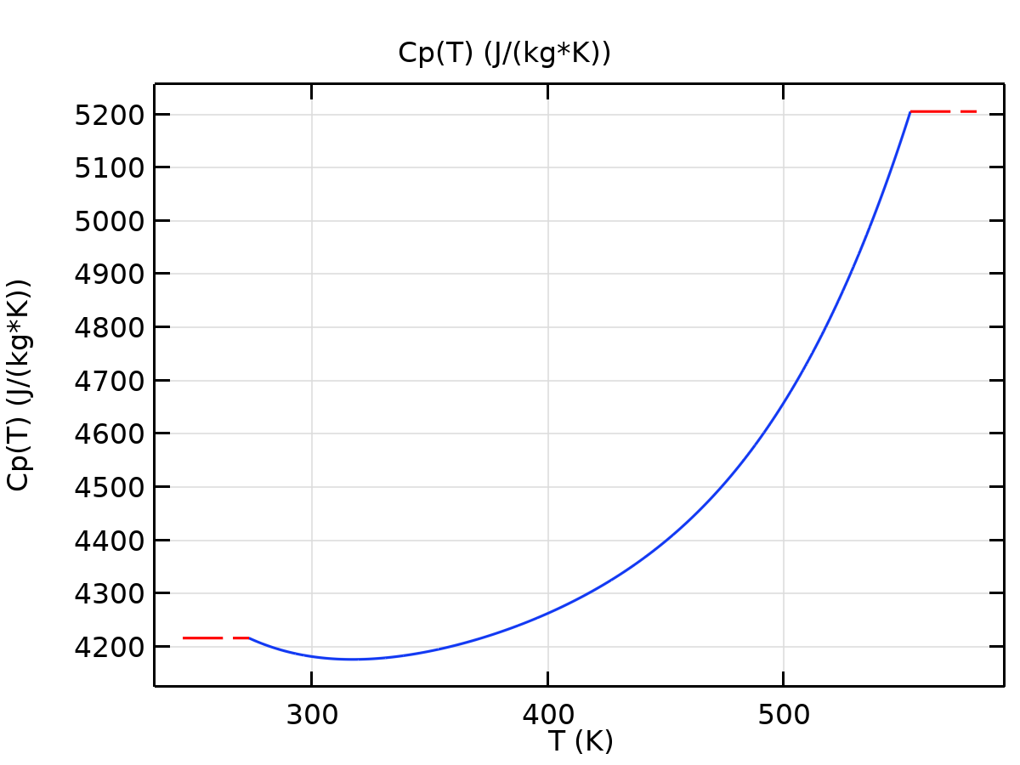

Cp

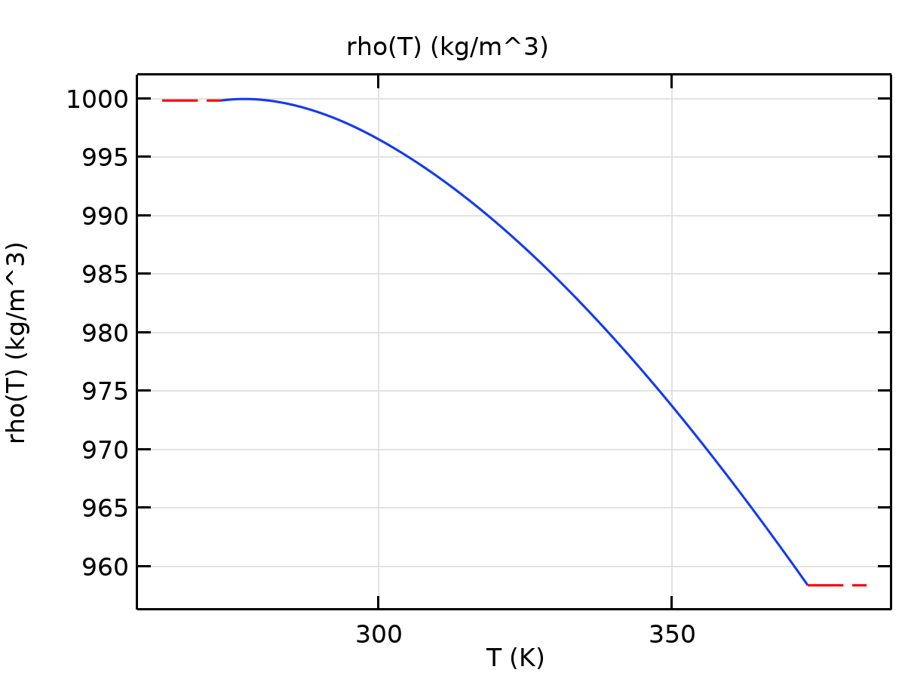

rho

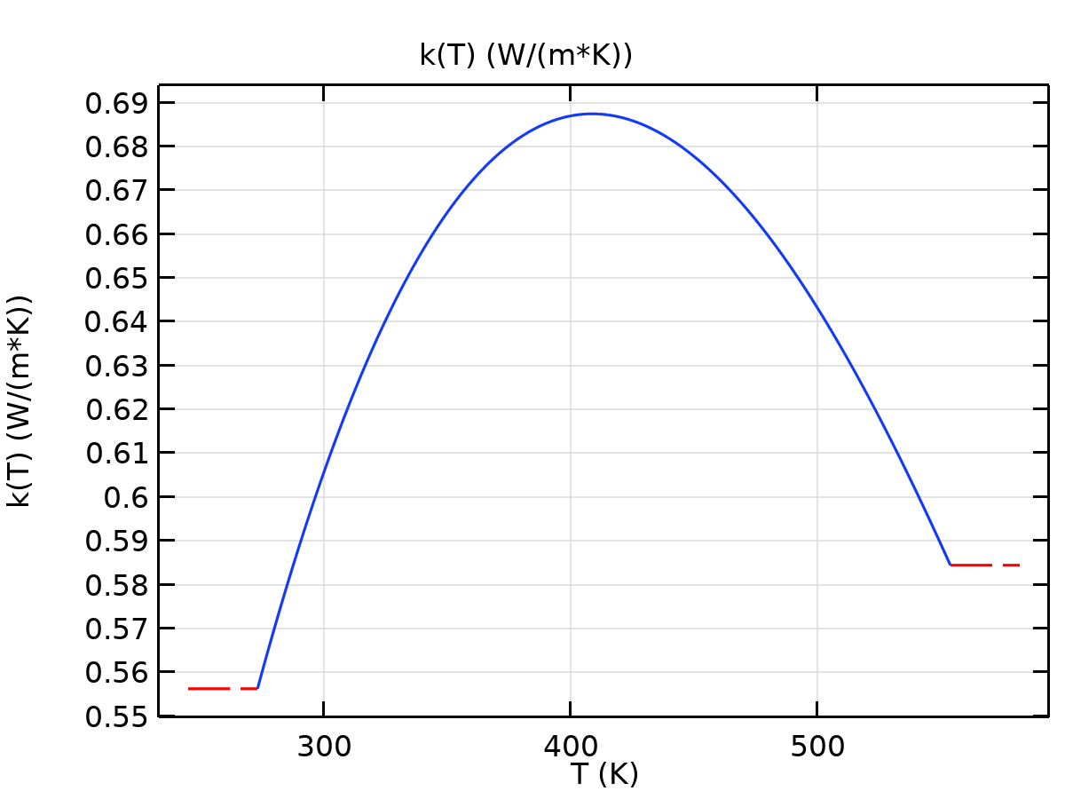

k

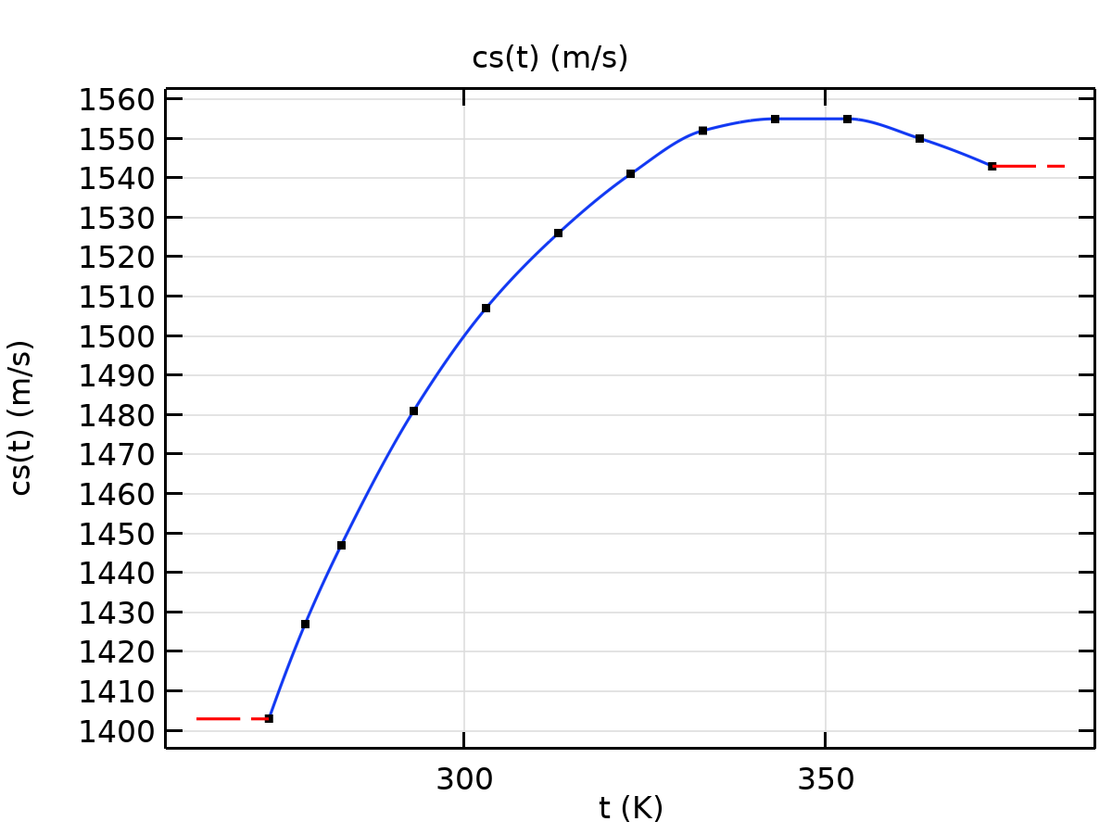

cs

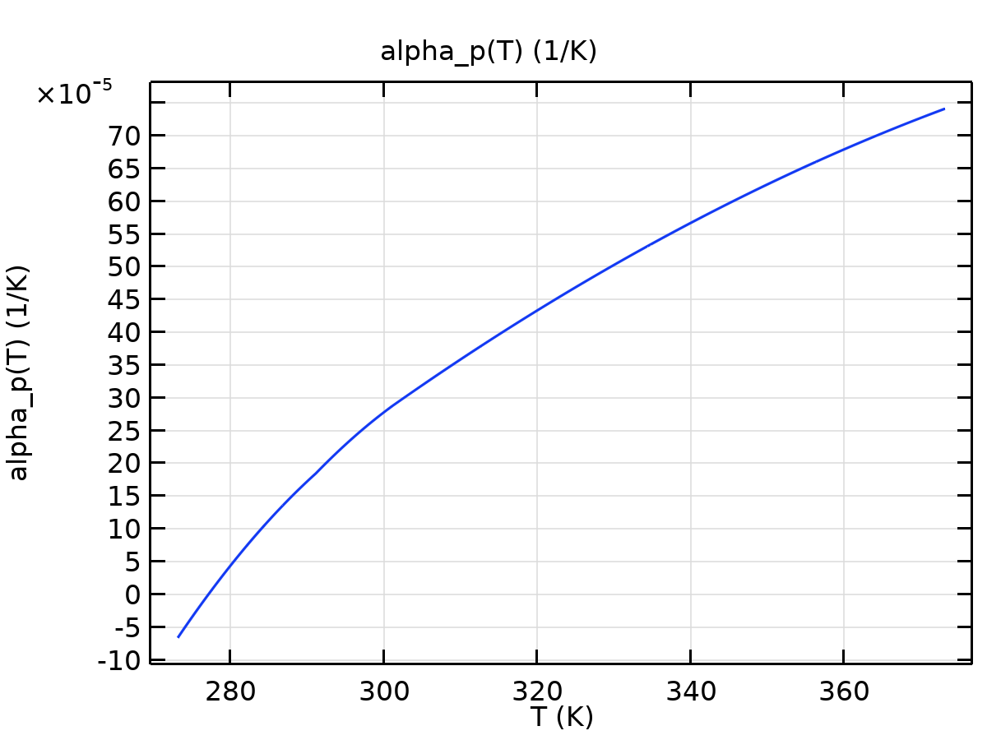

alpha_p

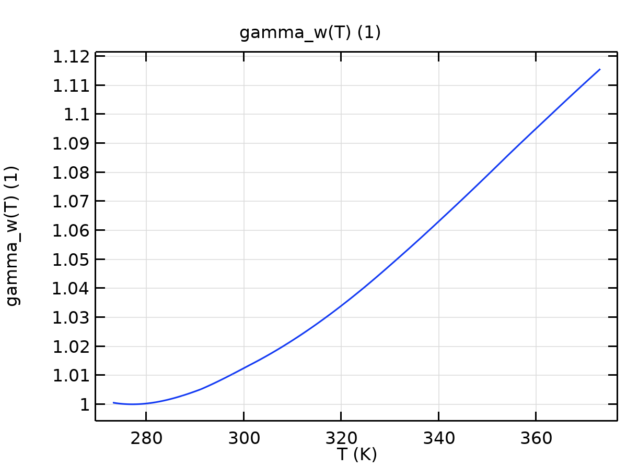

gamma_w

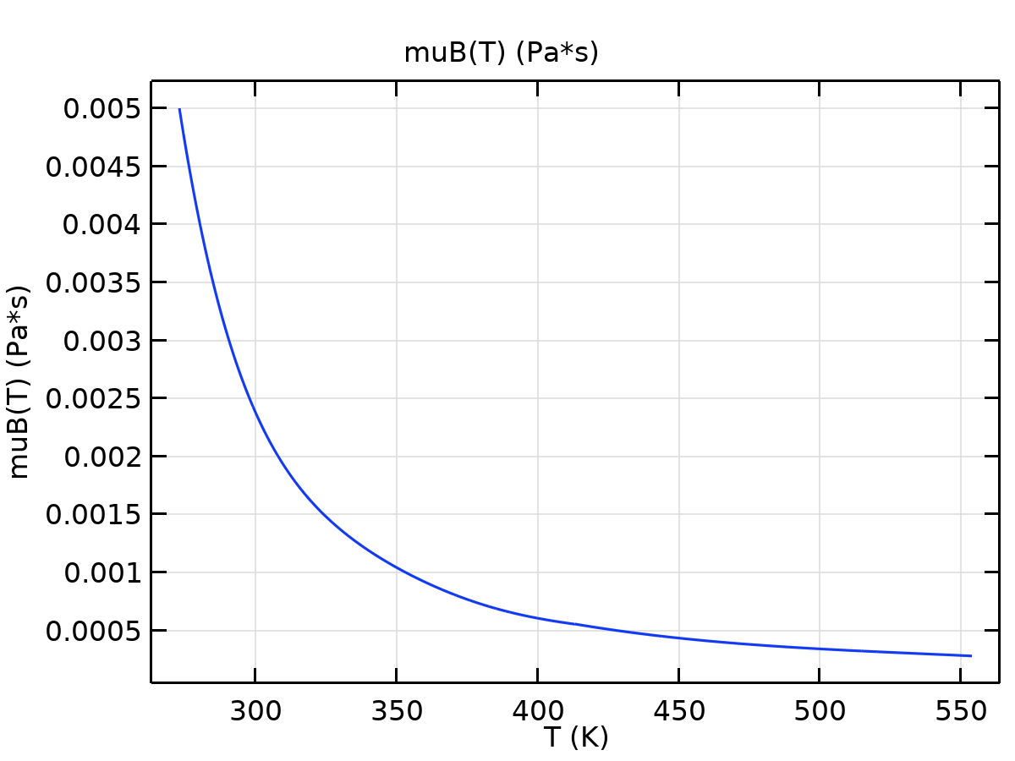

muB

* 1. Heat Transfer in Solids

Used products

|  |
| --- |
| COMSOL Multiphysics |



Heat Transfer in Solids

Selection

|  |  |
| --- | --- |
| Geometric entity level | Domain |
| Selection | Domain 1 |

Equations

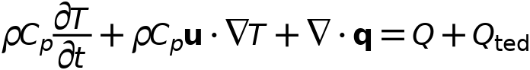



* + 1. Interface settings

#### Discretization

Settings

| **Description** | **Value** |
| --- | --- |
| Temperature | Quadratic Lagrange |

#### Physical model

Settings

| **Description** | **Value** |
| --- | --- |
| Heat transfer in biological tissue | Off |
| Isothermal domain | Off |
| Heat transfer in porous media | Off |
| Heat transfer in alloys | Off |
| Reference temperature | User defined |
| Reference temperature | 293.15[K] |

* + 1. Variables

| **Name** | **Expression** | **Unit** | **Description** | **Selection** | **Details** |
| --- | --- | --- | --- | --- | --- |
| ht.q0 | 0 | W/m² | Inward heat flux | Boundaries 1–5, 8, 12, 18 | + operation |
| ht.Tu | T | K | Temperature | Boundaries 1–5, 8, 12, 18 |  |
| ht.Td | T | K | Temperature | Boundaries 1–5, 8, 12, 18 |  |
| ht.Tref | model.input.Tref | K | Reference temperature | Global | Meta |
| ht.d | 1 | 1 | Thickness | Domain 1 |  |
| ht.HRef | 0 | J/kg | Reference enthalpy | Domain 1 |  |
| ht.DeltaH | 0 | J/kg | Sensible enthalpy | Domain 1 | + operation |
| ht.H | 0 | J/kg | Enthalpy | Domain 1 | + operation |
| ht.H0 | ht.H+ht.Ek | J/kg | Total enthalpy | Domain 1 |  |
| ht.Ei | 0 | J/kg | Internal energy | Domain 1 | + operation |
| ht.Ei0 | ht.Ei+ht.Ek | J/kg | Total internal energy | Domain 1 |  |
| ht.Ek | 0 | J/kg | Kinetic energy | Domain 1 | + operation |
| ht.dfluxx | 0 | W/m² | Conductive heat flux, x component | Domain 1 | + operation |
| ht.dfluxy | 0 | W/m² | Conductive heat flux, y component | Domain 1 | + operation |
| ht.dfluxz | 0 | W/m² | Conductive heat flux, z component | Domain 1 | + operation |
| ht.dfluxx | mean(ht.dfluxx) | W/m² | Conductive heat flux, x component | Boundaries 1–5, 8, 12, 18 | + operation |
| ht.dfluxy | mean(ht.dfluxy) | W/m² | Conductive heat flux, y component | Boundaries 1–5, 8, 12, 18 | + operation |
| ht.dfluxz | mean(ht.dfluxz) | W/m² | Conductive heat flux, z component | Boundaries 1–5, 8, 12, 18 | + operation |
| ht.dfluxtestx | 0 | W/m² | Conductive heat flux, x component | Domain 1 | + operation |
| ht.dfluxtesty | 0 | W/m² | Conductive heat flux, y component | Domain 1 | + operation |
| ht.dfluxtestz | 0 | W/m² | Conductive heat flux, z component | Domain 1 | + operation |
| ht.dfluxtestx | mean(ht.dfluxtestx) | W/m² | Conductive heat flux, x component | Boundaries 1–5, 8, 12, 18 | + operation |
| ht.dfluxtesty | mean(ht.dfluxtesty) | W/m² | Conductive heat flux, y component | Boundaries 1–5, 8, 12, 18 | + operation |
| ht.dfluxtestz | mean(ht.dfluxtestz) | W/m² | Conductive heat flux, z component | Boundaries 1–5, 8, 12, 18 | + operation |
| ht.dfluxMag | sqrt(ht.dfluxx^2+ht.dfluxy^2+ht.dfluxz^2) | W/m² | Conductive heat flux magnitude | Domain 1 |  |
| ht.cfluxx | 0 | W/m² | Convective heat flux, x component | Domain 1 | + operation |
| ht.cfluxy | 0 | W/m² | Convective heat flux, y component | Domain 1 | + operation |
| ht.cfluxz | 0 | W/m² | Convective heat flux, z component | Domain 1 | + operation |
| ht.cfluxMag | sqrt(ht.cfluxx^2+ht.cfluxy^2+ht.cfluxz^2) | W/m² | Convective heat flux magnitude | Domain 1 |  |
| ht.tfluxx | ht.dfluxx+ht.cfluxx | W/m² | Total heat flux, x component | Domain 1 |  |
| ht.tfluxy | ht.dfluxy+ht.cfluxy | W/m² | Total heat flux, y component | Domain 1 |  |
| ht.tfluxz | ht.dfluxz+ht.cfluxz | W/m² | Total heat flux, z component | Domain 1 |  |
| ht.tfluxMag | sqrt(ht.tfluxx^2+ht.tfluxy^2+ht.tfluxz^2) | W/m² | Total heat flux magnitude | Domain 1 |  |
| ht.tefluxx | 0 | W/m² | Total energy flux, x component | Domain 1 | + operation |
| ht.tefluxy | 0 | W/m² | Total energy flux, y component | Domain 1 | + operation |
| ht.tefluxz | 0 | W/m² | Total energy flux, z component | Domain 1 | + operation |
| ht.tefluxMag | sqrt(ht.tefluxx^2+ht.tefluxy^2+ht.tefluxz^2) | W/m² | Total energy flux magnitude | Domain 1 |  |
| ht.dflux_ux | up(ht.dfluxx) | W/m² | Conductive heat flux, x component | Boundaries 1–5, 8, 12, 18 |  |
| ht.dflux_uy | up(ht.dfluxy) | W/m² | Conductive heat flux, y component | Boundaries 1–5, 8, 12, 18 |  |
| ht.dflux_uz | up(ht.dfluxz) | W/m² | Conductive heat flux, z component | Boundaries 1–5, 8, 12, 18 |  |
| ht.dflux_dx | down(ht.dfluxx) | W/m² | Conductive heat flux, x component | Boundaries 1–5, 8, 12, 18 |  |
| ht.dflux_dy | down(ht.dfluxy) | W/m² | Conductive heat flux, y component | Boundaries 1–5, 8, 12, 18 |  |
| ht.dflux_dz | down(ht.dfluxz) | W/m² | Conductive heat flux, z component | Boundaries 1–5, 8, 12, 18 |  |
| ht.dfluxtest_ux | up(ht.dfluxtestx) | W/m² | Conductive heat flux, x component | Boundaries 1–5, 8, 12, 18 |  |
| ht.dfluxtest_uy | up(ht.dfluxtesty) | W/m² | Conductive heat flux, y component | Boundaries 1–5, 8, 12, 18 |  |
| ht.dfluxtest_uz | up(ht.dfluxtestz) | W/m² | Conductive heat flux, z component | Boundaries 1–5, 8, 12, 18 |  |
| ht.dfluxtest_dx | down(ht.dfluxtestx) | W/m² | Conductive heat flux, x component | Boundaries 1–5, 8, 12, 18 |  |
| ht.dfluxtest_dy | down(ht.dfluxtesty) | W/m² | Conductive heat flux, y component | Boundaries 1–5, 8, 12, 18 |  |
| ht.dfluxtest_dz | down(ht.dfluxtestz) | W/m² | Conductive heat flux, z component | Boundaries 1–5, 8, 12, 18 |  |
| ht.rflux | 0 | W/m² | Radiative heat flux | Boundaries 1–5, 8, 12, 18 | + operation |
| ht.ncflux | mean(ht.cfluxx)*ht.nx+mean(ht.cfluxy)*ht.ny+mean(ht.cfluxz)*ht.nz | W/m² | Normal convective heat flux | Boundaries 1–5, 8, 12, 18 |  |
| ht.ncflux_u | up(ht.cfluxx)*ht.unx+up(ht.cfluxy)*ht.uny+up(ht.cfluxz)*ht.unz | W/m² | Internal normal convective heat flux, upside | Boundaries 1–5, 8, 12, 18 |  |
| ht.ncflux_d | down(ht.cfluxx)*ht.dnx+down(ht.cfluxy)*ht.dny+down(ht.cfluxz)*ht.dnz | W/m² | Internal normal convective heat flux, downside | Boundaries 1–5, 8, 12, 18 |  |
| ht.ndflux | 0.5*(ht.ndflux_d-ht.ndflux_u) | W/m² | Normal conductive heat flux | Boundaries 1–5, 8, 12, 18 | + operation |
| ht.ndflux_u | -ht.ndflux_d | W/m² | Internal normal conductive heat flux, upside | Boundaries 1–5, 8, 12, 18 | + operation |
| ht.ndflux_d | 0 | W/m² | Internal normal conductive heat flux, downside | Boundaries 1–5, 8, 12, 18 | + operation |
| ht.ntflux | ht.ndflux+ht.ncflux | W/m² | Normal total heat flux | Boundaries 1–5, 8, 12, 18 |  |
| ht.ntflux_u | ht.ndflux_u+ht.ncflux_u | W/m² | Internal normal total flux, upside | Boundaries 1–5, 8, 12, 18 |  |
| ht.ntflux_d | ht.ndflux_d+ht.ncflux_d | W/m² | Internal normal total flux, downside | Boundaries 1–5, 8, 12, 18 |  |
| ht.nteflux | mean(ht.tefluxx)*ht.nx+mean(ht.tefluxy)*ht.ny+mean(ht.tefluxz)*ht.nz-mean(ht.dfluxx)*ht.nx-mean(ht.dfluxy)*ht.ny-mean(ht.dfluxz)*ht.nz+ht.ndflux | W/m² | Normal total energy flux | Boundaries 1–5, 8, 12, 18 |  |
| ht.nteflux_u | up(ht.tefluxx)*ht.unx+up(ht.tefluxy)*ht.uny+up(ht.tefluxz)*ht.unz-up(ht.dfluxx)*ht.unx-up(ht.dfluxy)*ht.uny-up(ht.dfluxz)*ht.unz+ht.ndflux_u | W/m² | Internal normal total energy flux, upside | Boundaries 1–5, 8, 12, 18 |  |
| ht.nteflux_d | down(ht.tefluxx)*ht.dnx+down(ht.tefluxy)*ht.dny+down(ht.tefluxz)*ht.dnz-down(ht.dfluxx)*ht.dnx-down(ht.dfluxy)*ht.dny-down(ht.dfluxz)*ht.dnz+ht.ndflux_d | W/m² | Internal normal total energy flux, downside | Boundaries 1–5, 8, 12, 18 |  |
| ht.Qm | 0 | kg/(m³·s) | Mass source | Domain 1 |  |
| ht.Q | 0 | W/m³ | Heat source | Domain 1 | + operation |
| ht.Qoop | 0 | W/m³ | Out-of-plane heat source | Domain 1 | + operation |
| ht.Qtot | 0 | W/m³ | Total heat source | Domain 1 | + operation |
| ht.Qbtot | 0 | W/m² | Total boundary heat source | Boundaries 1–5, 8, 12, 18 | + operation |
| ht.qs | 0 | W/(m³·K) | Production/absorption coefficient | Domain 1 | + operation |
| ht.qs_oop | 0 | W/(m³·K) | Out-of-plane production/absorption coefficient | Domain 1 | + operation |
| ht.Tvar | T | K | Temperature | Domain 1 |  |
| ht.Tvar | T | K | Temperature | Boundaries 1–5, 8, 12, 18 |  |
| ht.Tvar | T | K | Temperature | Edges 1–8, 10–11, 15–16, 20, 23, 26, 29, 33–36 |  |
| ht.Tvar | T | K | Temperature | Points 1–5, 7, 9, 11, 13, 15, 17, 19, 21–24 |  |
| ht.nx | dnx | 1 | Normal vector, x component | Boundaries 1–5, 8, 12, 18 |  |
| ht.ny | dny | 1 | Normal vector, y component | Boundaries 1–5, 8, 12, 18 |  |
| ht.nz | dnz | 1 | Normal vector, z component | Boundaries 1–5, 8, 12, 18 |  |
| ht.nxmesh | dnxmesh | 1 | Normal vector (mesh), x component | Boundaries 1–5, 8, 12, 18 |  |
| ht.nymesh | dnymesh | 1 | Normal vector (mesh), y component | Boundaries 1–5, 8, 12, 18 |  |
| ht.nzmesh | dnzmesh | 1 | Normal vector (mesh), z component | Boundaries 1–5, 8, 12, 18 |  |
| ht.dnx | dnx | 1 | Normal vector down direction, x component | Boundaries 1–5, 8, 12, 18 |  |
| ht.dny | dny | 1 | Normal vector down direction, y component | Boundaries 1–5, 8, 12, 18 |  |
| ht.dnz | dnz | 1 | Normal vector down direction, z component | Boundaries 1–5, 8, 12, 18 |  |
| ht.unx | unx | 1 | Normal vector up direction, x component | Boundaries 1–5, 8, 12, 18 |  |
| ht.uny | uny | 1 | Normal vector up direction, y component | Boundaries 1–5, 8, 12, 18 |  |
| ht.unz | unz | 1 | Normal vector up direction, z component | Boundaries 1–5, 8, 12, 18 |  |
| ht.dEiInt | 0 | W | Total accumulated heat rate | Global | + operation |
| ht.dEi0Int | 0 | W | Total accumulated energy rate | Global | + operation |
| ht.ntfluxInt | ht.intExtBnd(ht.ntflux*ht.varIntSpa) | W | Total net heat rate | Global |  |
| ht.ntefluxInt | ht.intExtBnd(ht.nteflux*ht.varIntSpa) | W | Total net energy rate | Global |  |
| ht.QInt | ht.intDom(ht.Qtot*ht.varIntSpa)-ht.intIntBnd((ht.ndflux_u+ht.ndflux_d)*ht.varIntSpa) | W | Total heat source | Global |  |
| ht.WnsInt | 0 | W | Total work source | Global | + operation |
| ht.WInt | 0 | W | Total work source | Global | + operation |
| ht.varIntSpa | ht.d | 1 | Intermediate variable | Domain 1 |  |

* + 1. Solid 1



Solid 1

Selection

|  |  |
| --- | --- |
| Geometric entity level | Domain |
| Selection | Domain 1 |

Equations

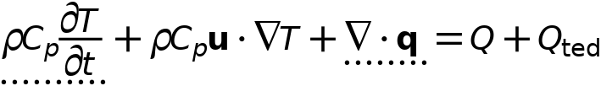



#### Heat conduction, solid

Settings

| **Description** | **Value** |
| --- | --- |
| Thermal conductivity | From material |

#### Thermodynamics, solid

Settings

| **Description** | **Value** |
| --- | --- |
| Density | From material |
| Heat capacity at constant pressure | From material |

#### Coordinate system selection

Settings

| **Description** | **Value** |
| --- | --- |
| Coordinate system | Global coordinate system |

#### Model input

Settings

| **Description** | **Value** |
| --- | --- |
| Volume reference temperature | Common model input |
| Absolute pressure | User defined |
| Absolute pressure | 1[atm] |

Properties from material

| **Property** | **Material** | **Property group** |
| --- | --- | --- |
| Thermal conductivity | Battery Block | Basic |
| Density | Battery Block | Basic |
| Heat capacity at constant pressure | Battery Block | Basic |

#### Variables

| **Name** | **Expression** | **Unit** | **Description** | **Selection** | **Details** |
| --- | --- | --- | --- | --- | --- |
| domflux.Tx | ht.dfluxx*ht.d | W/m² | Domain flux, x component | Domain 1 |  |
| domflux.Ty | ht.dfluxy*ht.d | W/m² | Domain flux, y component | Domain 1 |  |
| domflux.Tz | ht.dfluxz*ht.d | W/m² | Domain flux, z component | Domain 1 |  |
| ht.DeltaH | integrate(subst(ht.Cp,ht.solid1.minput_pressure,ht.pref),T,ht.Tref,T)+integrate(ht.mujtT,ht.solid1.minput_pressure,ht.pref,ht.pA) | J/kg | Sensible enthalpy | Domain 1 | + operation |
| ht.H | ht.HRef+ht.DeltaH | J/kg | Enthalpy | Domain 1 | + operation |
| ht.Ei | ht.H | J/kg | Internal energy | Domain 1 | + operation |
| ht.Ek | 0.5*(ht.ux^2+ht.uy^2+ht.uz^2) | J/kg | Kinetic energy | Domain 1 | + operation |
| ht.dfluxx | -ht.k_effxx*Tx-ht.k_effxy*Ty-ht.k_effxz*Tz | W/m² | Conductive heat flux, x component | Domain 1 | + operation |
| ht.dfluxy | -ht.k_effyx*Tx-ht.k_effyy*Ty-ht.k_effyz*Tz | W/m² | Conductive heat flux, y component | Domain 1 | + operation |
| ht.dfluxz | -ht.k_effzx*Tx-ht.k_effzy*Ty-ht.k_effzz*Tz | W/m² | Conductive heat flux, z component | Domain 1 | + operation |
| ht.dfluxtestx | -ht.k_effxx*test(Tx)-ht.k_effxy*test(Ty)-ht.k_effxz*test(Tz) | W/m² | Conductive heat flux, x component | Domain 1 | + operation |
| ht.dfluxtesty | -ht.k_effyx*test(Tx)-ht.k_effyy*test(Ty)-ht.k_effyz*test(Tz) | W/m² | Conductive heat flux, y component | Domain 1 | + operation |
| ht.dfluxtestz | -ht.k_effzx*test(Tx)-ht.k_effzy*test(Ty)-ht.k_effzz*test(Tz) | W/m² | Conductive heat flux, z component | Domain 1 | + operation |
| ht.cfluxx | ht.rho*ht.ux*ht.Ei | W/m² | Convective heat flux, x component | Domain 1 | + operation |
| ht.cfluxy | ht.rho*ht.uy*ht.Ei | W/m² | Convective heat flux, y component | Domain 1 | + operation |
| ht.cfluxz | ht.rho*ht.uz*ht.Ei | W/m² | Convective heat flux, z component | Domain 1 | + operation |
| ht.tefluxx | ht.dfluxx+ht.rho*ht.ux*ht.H0 | W/m² | Total energy flux, x component | Domain 1 | + operation |
| ht.tefluxy | ht.dfluxy+ht.rho*ht.uy*ht.H0 | W/m² | Total energy flux, y component | Domain 1 | + operation |
| ht.tefluxz | ht.dfluxz+ht.rho*ht.uz*ht.H0 | W/m² | Total energy flux, z component | Domain 1 | + operation |
| ht.ndflux_d | -dflux_spatial(T)/ht.d | W/m² | Internal normal conductive heat flux, downside | Boundaries 1–5, 8, 12, 18 | + operation |
| ht.dEiInt | ht.solid1.dEiInt | W | Total accumulated heat rate | Global | + operation |
| ht.dEi0Int | ht.solid1.dEi0Int | W | Total accumulated energy rate | Global | + operation |
| ht.WnsInt | ht.solid1.WnsInt | W | Total work source | Global | + operation |
| ht.kxx | material.k11 | W/(m·K) | Thermal conductivity, xx component | Domain 1 | Meta |
| ht.kyx | material.k21 | W/(m·K) | Thermal conductivity, yx component | Domain 1 | Meta |
| ht.kzx | material.k31 | W/(m·K) | Thermal conductivity, zx component | Domain 1 | Meta |
| ht.kxy | material.k12 | W/(m·K) | Thermal conductivity, xy component | Domain 1 | Meta |
| ht.kyy | material.k22 | W/(m·K) | Thermal conductivity, yy component | Domain 1 | Meta |
| ht.kzy | material.k32 | W/(m·K) | Thermal conductivity, zy component | Domain 1 | Meta |
| ht.kxz | material.k13 | W/(m·K) | Thermal conductivity, xz component | Domain 1 | Meta |
| ht.kyz | material.k23 | W/(m·K) | Thermal conductivity, yz component | Domain 1 | Meta |
| ht.kzz | material.k33 | W/(m·K) | Thermal conductivity, zz component | Domain 1 | Meta |
| ht.k_iso | material.k_iso | W/(m·K) | Thermal conductivity, isotropic value | Domain 1 | Meta |
| ht.rho | material.rho | kg/m³ | Density | Domain 1 | Meta |
| ht.Cp | material.Cp | J/(kg·K) | Heat capacity at constant pressure | Domain 1 | Meta |
| ht.solid1.pref | 1[atm] | Pa | Reference pressure level | Domain 1 |  |
| ht.res_T | Tt*ht.C_eff-ht.k_effxx*Txx-ht.k_effxy*Txy-ht.k_effxz*Txz-ht.k_effyx*Tyx-ht.k_effyy*Tyy-ht.k_effyz*Tyz-ht.k_effzx*Tzx-ht.k_effzy*Tzy-ht.k_effzz*Tzz-(ht.qs+ht.qs_oop)*T+ht.rho*ht.Cp*(ht.ux*Tx+ht.uy*Ty+ht.uz*Tz)-ht.Q-ht.Qoop | W/m³ | Equation residual | Domain 1 | + operation |
| ht.alphap | -d(ht.rho,T)/(ht.rho+eps) | 1/K | Isobaric compressibility coefficient | Domain 1 |  |
| ht.pA | ht.pref | Pa | Absolute pressure | Domain 1 |  |
| ht.gradTmag | sqrt(ht.gradTx^2+ht.gradTy^2+ht.gradTz^2) | K/m | Temperature gradient magnitude | Domain 1 |  |
| ht.Qmet | 0 | W/m³ | Metabolic heat source | Domain 1 | + operation |
| ht.pref | ht.solid1.pref | Pa | Reference pressure level | Domain 1 |  |
| ht.rhoInit | subst(ht.rho,ht.solid1.minput_pressure,1[atm],T,ht.Tinit) | kg/m³ | Initial density | Domain 1 |  |
| ht.rho_eff | ht.rho | kg/m³ | Effective density | Domain 1 |  |
| ht.C_eff | ht.rho*ht.Cp | J/(m³·K) | Effective volumetric heat capacity | Domain 1 |  |
| ht.mujtT | 0 | m³/kg | Isothermal Joule-Thomson coefficient | Domain 1 |  |
| ht.k_effxx | ht.kxx | W/(m·K) | Effective thermal conductivity, xx component | Domain 1 |  |
| ht.k_effyx | ht.kyx | W/(m·K) | Effective thermal conductivity, yx component | Domain 1 |  |
| ht.k_effzx | ht.kzx | W/(m·K) | Effective thermal conductivity, zx component | Domain 1 |  |
| ht.k_effxy | ht.kxy | W/(m·K) | Effective thermal conductivity, xy component | Domain 1 |  |
| ht.k_effyy | ht.kyy | W/(m·K) | Effective thermal conductivity, yy component | Domain 1 |  |
| ht.k_effzy | ht.kzy | W/(m·K) | Effective thermal conductivity, zy component | Domain 1 |  |
| ht.k_effxz | ht.kxz | W/(m·K) | Effective thermal conductivity, xz component | Domain 1 |  |
| ht.k_effyz | ht.kyz | W/(m·K) | Effective thermal conductivity, yz component | Domain 1 |  |
| ht.k_effzz | ht.kzz | W/(m·K) | Effective thermal conductivity, zz component | Domain 1 |  |
| ht.kappaTxx | 0 | W/(m·K) | Turbulent thermal conductivity, xx component | Domain 1 |  |
| ht.kappaTyx | 0 | W/(m·K) | Turbulent thermal conductivity, yx component | Domain 1 |  |
| ht.kappaTzx | 0 | W/(m·K) | Turbulent thermal conductivity, zx component | Domain 1 |  |
| ht.kappaTxy | 0 | W/(m·K) | Turbulent thermal conductivity, xy component | Domain 1 |  |
| ht.kappaTyy | 0 | W/(m·K) | Turbulent thermal conductivity, yy component | Domain 1 |  |
| ht.kappaTzy | 0 | W/(m·K) | Turbulent thermal conductivity, zy component | Domain 1 |  |
| ht.kappaTxz | 0 | W/(m·K) | Turbulent thermal conductivity, xz component | Domain 1 |  |
| ht.kappaTyz | 0 | W/(m·K) | Turbulent thermal conductivity, yz component | Domain 1 |  |
| ht.kappaTzz | 0 | W/(m·K) | Turbulent thermal conductivity, zz component | Domain 1 |  |
| ht.kmean | (ht.k_effxx+ht.k_effyy+ht.k_effzz)/3 | W/(m·K) | Mean effective thermal conductivity | Domain 1 |  |
| ht.ux | 0 | m/s | Velocity field, x component | Domain 1 | + operation |
| ht.uy | 0 | m/s | Velocity field, y component | Domain 1 | + operation |
| ht.uz | 0 | m/s | Velocity field, z component | Domain 1 | + operation |
| ht.gradTx | Tx | K/m | Temperature gradient, x component | Domain 1 |  |
| ht.gradTy | Ty | K/m | Temperature gradient, y component | Domain 1 |  |
| ht.gradTz | Tz | K/m | Temperature gradient, z component | Domain 1 |  |
| ht.cellPe | 0.5*ht.rho*ht.Cp*h*sqrt(ht.ux^2+ht.uy^2+ht.uz^2)/ht.kmean | 1 | Cell Péclet number | Domain 1 |  |
| ht.Qltot | 0 | W/m | Total line heat source | Edges 1–8, 10–11, 15–16, 20, 23, 26, 29, 33–36 | + operation |
| ht.Qptot | 0 | W | Total point heat source | Points 1–5, 7, 9, 11, 13, 15, 17, 19, 21–24 | + operation |
| ht.alphaTdxx | ht.k_effxx/ht.C_eff | m²/s | Thermal diffusivity, xx component | Domain 1 |  |
| ht.alphaTdyx | ht.k_effyx/ht.C_eff | m²/s | Thermal diffusivity, yx component | Domain 1 |  |
| ht.alphaTdzx | ht.k_effzx/ht.C_eff | m²/s | Thermal diffusivity, zx component | Domain 1 |  |
| ht.alphaTdxy | ht.k_effxy/ht.C_eff | m²/s | Thermal diffusivity, xy component | Domain 1 |  |
| ht.alphaTdyy | ht.k_effyy/ht.C_eff | m²/s | Thermal diffusivity, yy component | Domain 1 |  |
| ht.alphaTdzy | ht.k_effzy/ht.C_eff | m²/s | Thermal diffusivity, zy component | Domain 1 |  |
| ht.alphaTdxz | ht.k_effxz/ht.C_eff | m²/s | Thermal diffusivity, xz component | Domain 1 |  |
| ht.alphaTdyz | ht.k_effyz/ht.C_eff | m²/s | Thermal diffusivity, yz component | Domain 1 |  |
| ht.alphaTdzz | ht.k_effzz/ht.C_eff | m²/s | Thermal diffusivity, zz component | Domain 1 |  |
| ht.alphaTdMean | ht.kmean/ht.C_eff | m²/s | Mean thermal diffusivity | Domain 1 |  |
| ht.Tradu | ht.Tu | K | Upside temperature | Domain 1 |  |
| ht.Tradu | ht.Tu | K | Upside temperature | Boundaries 1–5, 8, 12, 18 |  |
| ht.Tradd | ht.Td | K | Downside temperature | Domain 1 |  |
| ht.Tradd | ht.Td | K | Downside temperature | Boundaries 1–5, 8, 12, 18 |  |
| ht.solid1.dEiInt | ht.solid1.intDom((ht.dEi-ht.Qm*ht.Ei)*ht.solid1.varIntSpa) | W | Total accumulated heat rate | Global |  |
| ht.dEi | d(ht.rho*ht.Ei,t) | W/m³ | Total accumulated heat rate density | Domain 1 |  |
| ht.solid1.dEi0Int | ht.solid1.intDom((ht.dEi0-ht.Qm*ht.H)*ht.solid1.varIntSpa) | W | Total accumulated energy rate | Global |  |
| ht.dEi0 | d(ht.rho*ht.Ei0,t) | W/m³ | Total accumulated energy rate density | Domain 1 |  |
| ht.solid1.ntfluxInt | ht.solid1.intExtBnd(ht.ntflux*ht.solid1.varIntSpa)+ht.solid1.intExtBndUp(ht.ntflux_u*ht.solid1.varIntSpa)+ht.solid1.intExtBndDown(ht.ntflux_d*ht.solid1.varIntSpa) | W | Total net heat rate | Global |  |
| ht.solid1.ntefluxInt | ht.solid1.intExtBnd(ht.nteflux*ht.solid1.varIntSpa)+ht.solid1.intExtBndUp(ht.nteflux_u*ht.solid1.varIntSpa)+ht.solid1.intExtBndDown(ht.nteflux_d*ht.solid1.varIntSpa) | W | Total net energy rate | Global |  |
| ht.solid1.QInt | ht.solid1.intDom(ht.Qtot*ht.solid1.varIntSpa)-ht.solid1.intIntBnd((ht.ndflux_u+ht.ndflux_d)*ht.solid1.varIntSpa) | W | Total heat source | Global |  |
| ht.solid1.WnsInt | ht.solid1.intDom(ht.pA*(d(ht.ux,x)+d(ht.uy,y)+d(ht.uz,z))*ht.solid1.varIntSpa) | W | Total work source | Global |  |
| ht.solid1.WInt | 0 | W | Total work source | Global |  |
| ht.solid1.varIntSpa | ht.d | 1 | Intermediate variable | Domain 1 |  |
| ht.timeDerivative | Tt | K/s | Temperature, first time derivative | Domain 1 |  |
| ht.gamma | 1 | 1 | Ratio of specific heats | Domain 1 |  |
| ht.Trho | ht.Tref | K | Temperature for density evaluation | Domain 1 |  |
| ht.dfltopaque | 1 | 1 | Default opacity | Domain 1 |  |
| ht.helem | h_spatial | m | Element size | Domain 1 |  |

#### Shape functions

| **Name** | **Shape function** | **Unit** | **Description** | **Shape frame** | **Selection** |
| --- | --- | --- | --- | --- | --- |
| T | Lagrange (Quadratic) | K | Temperature | Spatial | Domain 1 |

#### Weak expressions

| **Weak expression** | **Integration order** | **Integration frame** | **Selection** |
| --- | --- | --- | --- |
| ht.streamline | 4 | Spatial | Domain 1 |
| (ht.dfluxx*test(Tx)+ht.dfluxy*test(Ty)+ht.dfluxz*test(Tz))*ht.d | 4 | Spatial | Domain 1 |
| -ht.C_eff*ht.timeDerivative*test(T)*ht.d | 4 | Spatial | Domain 1 |
| -ht.rho*ht.Cp*(ht.ux*Tx+ht.uy*Ty+ht.uz*Tz)*test(T)*ht.d | 4 | Spatial | Domain 1 |

* + 1. Initial Values 1



Initial Values 1

Selection

|  |  |
| --- | --- |
| Geometric entity level | Domain |
| Selection | Domain 1 |

#### Initial values

Settings

| **Description** | **Value** |
| --- | --- |
| Temperature | User defined |
| Temperature | 333.15[K] |

#### Variables

| **Name** | **Expression** | **Unit** | **Description** | **Selection** |
| --- | --- | --- | --- | --- |
| ht.Tinit | 333.15[K] | K | Temperature | Domain 1 |

* + 1. Thermal Insulation 1



Thermal Insulation 1

Selection

|  |  |
| --- | --- |
| Geometric entity level | Boundary |
| Selection | Boundaries 1–5, 8, 12, 18 |

Equations



#### Variables

| **Name** | **Expression** | **Unit** | **Description** | **Selection** |
| --- | --- | --- | --- | --- |
| ht.ins1.Tave | nojac(ht.ins1.intBnd(ht.ins1.varIntSpa*ht.rho*ht.Cp*T*max(abs(ht.ux*ht.nx+ht.uy*ht.ny+ht.uz*ht.nz),eps)))/nojac(ht.ins1.intBnd(ht.ins1.varIntSpa*ht.rho*ht.Cp*max(abs(ht.ux*ht.nx+ht.uy*ht.ny+ht.uz*ht.nz),eps))) | K | Weighted average temperature | Global |
| ht.ins1.ntfluxInt | ht.ins1.intExtBnd(ht.ntflux*ht.ins1.varIntSpa) | W | Total net heat rate | Global |
| ht.ins1.ntefluxInt | ht.ins1.intExtBnd(ht.nteflux*ht.ins1.varIntSpa) | W | Total net energy rate | Global |
| ht.ins1.ntfluxInt_u | ht.ins1.intIntBnd(ht.ntflux_u*ht.ins1.varIntSpa) | W | Total net heat rate, upside | Global |
| ht.ins1.ntefluxInt_u | ht.ins1.intIntBnd(ht.nteflux_u*ht.ins1.varIntSpa) | W | Total net energy rate, upside | Global |
| ht.ins1.ntfluxInt_d | ht.ins1.intIntBnd(ht.ntflux_d*ht.ins1.varIntSpa) | W | Total net heat rate, downside | Global |
| ht.ins1.ntefluxInt_d | ht.ins1.intIntBnd(ht.nteflux_d*ht.ins1.varIntSpa) | W | Total net energy rate, downside | Global |
| ht.ins1.varIntSpa | ht.d | 1 | Intermediate variable | Boundaries 1–5, 8, 12, 18 |

#### Shape functions

| **Name** | **Shape function** | **Unit** | **Description** | **Shape frame** | **Selection** | **Details** |
| --- | --- | --- | --- | --- | --- | --- |
| T | Lagrange (Quadratic) | K | Temperature | Spatial | No boundaries | Slit |
| T | Lagrange (Quadratic) | K | Temperature | Material | No boundaries | Slit |
| T | Lagrange (Quadratic) | K | Temperature | Geometry | No boundaries | Slit |
| T | Lagrange (Quadratic) | K | Temperature | Mesh | No boundaries | Slit |

* + 1. Heat Source 1



Heat Source 1

Selection

|  |  |
| --- | --- |
| Geometric entity level | Domain |
| Selection | Domain 1 |

Equations



#### Heat source

Settings

| **Description** | **Value** |
| --- | --- |
| Heat source | General source |
| Heat source | User defined |
| Heat source | 5000 |

#### Variables

| **Name** | **Expression** | **Unit** | **Description** | **Selection** | **Details** |
| --- | --- | --- | --- | --- | --- |
| ht.Q | ht.hs1.Q | W/m³ | Heat source | Domain 1 | + operation |
| ht.Qtot | ht.hs1.Q | W/m³ | Total heat source | Domain 1 | + operation |
| ht.hs1.Q0 | 5000 | W/m³ | Heat source | Domain 1 |  |
| ht.hs1.Q | ht.hs1.Q0*spatial.detInvF | W/m³ | Heat source | Domain 1 |  |

#### Weak expressions

| **Weak expression** | **Integration order** | **Integration frame** | **Selection** |
| --- | --- | --- | --- |
| ht.hs1.Q*test(T)*ht.d*spatial.detF | 4 | Material | Domain 1 |

* 1. Laminar Flow

Used products

|  |
| --- |
| COMSOL Multiphysics |



Laminar Flow

Selection

|  |  |
| --- | --- |
| Geometric entity level | Domain |
| Selection | Domains 2–3 |

Equations

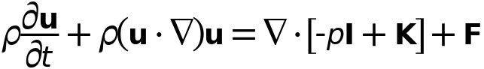



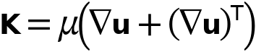

* + 1. Interface settings

#### Discretization

Settings

| **Description** | **Value** |
| --- | --- |
| Discretization of fluids | P1 + P1 |

#### Physical model

Settings

| **Description** | **Value** |
| --- | --- |
| Neglect inertial term (Stokes flow) | Off |
| Compressibility | Incompressible flow |
| Enable porous media domains | Off |
| Include gravity | Off |
| Reference temperature | User defined |
| Reference temperature | 293.15[K] |
| Reference pressure level | 1[atm] |

#### Turbulence

Settings

| **Description** | **Value** |
| --- | --- |
| Turbulence model type | None |

* + 1. Variables

| **Name** | **Expression** | **Unit** | **Description** | **Selection** | **Details** |
| --- | --- | --- | --- | --- | --- |
| spf.Tref | model.input.Tref | K | Reference temperature | Global | Meta |
| spf.dz | 1 | m | Thickness | Domains 2–3 |  |
| spf.pref | 1[atm] | Pa | Reference pressure level | Domains 2–3 |  |
| spf.pA | p+spf.pref | Pa | Absolute pressure | Domains 2–3 |  |
| spf.hasWF | 0 |  | Help variable | Boundaries 6–17 |  |
| spf.usePseudoTimeStepping | 0 | 1 | Help variable | Global | + operation |
| spf.localCFLvalue | 1.3^min(niterCMP,9)+if(niterCMP>=25,9*1.3^min(-25+niterCMP,9),0)+if(niterCMP>=45,90*1.3^min(-45+niterCMP,9),0) |  | Local CFL number | Domains 2–3 |  |
| spf.locCFL | CFLCMP | 1 | Local CFL number | Domains 2–3 |  |
| spf.geometryLengthScale | 0.025000000000000005 | m | Geometry length scale | Domains 2–3 |  |
| spf.time_step_inv | max(sqrt(emetric_spatial(u,v,w)*2^gmg_level^2),spf.nu/spf.geometryLengthScale^2) | Hz | Inverse time step | Domains 2–3 |  |
| spf.tsti | nojac(spf.time_step_inv/spf.locCFL) | 1/s | Help variable | Domains 2–3 |  |
| spf.nx | unx | 1 | Normal vector, x component | Boundaries 8, 12 |  |
| spf.ny | uny | 1 | Normal vector, y component | Boundaries 8, 12 |  |
| spf.nz | unz | 1 | Normal vector, z component | Boundaries 8, 12 |  |
| spf.nx | dnx | 1 | Normal vector, x component | Boundaries 6–7, 9–11, 13–17 |  |
| spf.ny | dny | 1 | Normal vector, y component | Boundaries 6–7, 9–11, 13–17 |  |
| spf.nz | dnz | 1 | Normal vector, z component | Boundaries 6–7, 9–11, 13–17 |  |
| spf.nxmesh | unxmesh | 1 | Normal vector, x component | Boundaries 8, 12 |  |
| spf.nymesh | unymesh | 1 | Normal vector, y component | Boundaries 8, 12 |  |
| spf.nzmesh | unzmesh | 1 | Normal vector, z component | Boundaries 8, 12 |  |
| spf.nxmesh | dnxmesh | 1 | Normal vector, x component | Boundaries 6–7, 9–11, 13–17 |  |
| spf.nymesh | dnymesh | 1 | Normal vector, y component | Boundaries 6–7, 9–11, 13–17 |  |
| spf.nzmesh | dnzmesh | 1 | Normal vector, z component | Boundaries 6–7, 9–11, 13–17 |  |

* + 1. Fluid Properties 1



Fluid Properties 1

Selection

|  |  |
| --- | --- |
| Geometric entity level | Domain |
| Selection | Domains 2–3 |

Equations

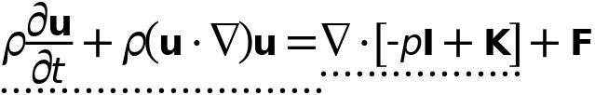





#### Fluid properties

Settings

| **Description** | **Value** |
| --- | --- |
| Density | From material |
| Dynamic viscosity | From material |

#### Model input

Settings

| **Description** | **Value** |
| --- | --- |
| Temperature | Common model input |

Properties from material

| **Property** | **Material** | **Property group** |
| --- | --- | --- |
| Density | Water, liquid | Basic |
| Dynamic viscosity | Water, liquid | Basic |

#### Variables

| **Name** | **Expression** | **Unit** | **Description** | **Selection** | **Details** |
| --- | --- | --- | --- | --- | --- |
| spf.rho | subst(material.rho,spf.fp1.minput_temperature,spf.Trho,spf.fp1.minput_pressure,spf.prho) | kg/m³ | Density | Domains 2–3 | Meta |
| spf.mu | material.mu | Pa·s | Dynamic viscosity | Domains 2–3 | Meta |
| spf.Trho | spf.Tref | K | Temperature for density evaluation | Domains 2–3 |  |
| spf.prho | spf.pref | Pa | Pressure for the evaluation of density | Domains 2–3 |  |
| spf.rhoref | subst(material.rho,spf.fp1.minput_temperature,spf.Tref,spf.fp1.minput_pressure,spf.pref) | kg/m³ | Reference density | Domains 2–3 | Meta |
| spf.mumat | material.mu | Pa·s | Dynamic viscosity | Domains 2–3 | Meta |
| spf.srijxx | ux | 1/s | Strain rate tensor, xx component | Domains 2–3 |  |
| spf.srijyx | 0.5*(vx+uy) | 1/s | Strain rate tensor, yx component | Domains 2–3 |  |
| spf.srijzx | 0.5*(wx+uz) | 1/s | Strain rate tensor, zx component | Domains 2–3 |  |
| spf.srijxy | 0.5*(uy+vx) | 1/s | Strain rate tensor, xy component | Domains 2–3 |  |
| spf.srijyy | vy | 1/s | Strain rate tensor, yy component | Domains 2–3 |  |
| spf.srijzy | 0.5*(wy+vz) | 1/s | Strain rate tensor, zy component | Domains 2–3 |  |
| spf.srijxz | 0.5*(uz+wx) | 1/s | Strain rate tensor, xz component | Domains 2–3 |  |
| spf.srijyz | 0.5*(vz+wy) | 1/s | Strain rate tensor, yz component | Domains 2–3 |  |
| spf.srijzz | wz | 1/s | Strain rate tensor, zz component | Domains 2–3 |  |
| spf.srijmeanxx | 0.5*root.comp1.spf.elemint(2*ux)/root.comp1.spf.elemint(1) | 1/s | Strain rate tensor, xx component | Domains 2–3 |  |
| spf.srijmeanyx | 0.5*root.comp1.spf.elemint(vx+uy)/root.comp1.spf.elemint(1) | 1/s | Strain rate tensor, yx component | Domains 2–3 |  |
| spf.srijmeanzx | 0.5*root.comp1.spf.elemint(wx+uz)/root.comp1.spf.elemint(1) | 1/s | Strain rate tensor, zx component | Domains 2–3 |  |
| spf.srijmeanxy | 0.5*root.comp1.spf.elemint(uy+vx)/root.comp1.spf.elemint(1) | 1/s | Strain rate tensor, xy component | Domains 2–3 |  |
| spf.srijmeanyy | 0.5*root.comp1.spf.elemint(2*vy)/root.comp1.spf.elemint(1) | 1/s | Strain rate tensor, yy component | Domains 2–3 |  |
| spf.srijmeanzy | 0.5*root.comp1.spf.elemint(wy+vz)/root.comp1.spf.elemint(1) | 1/s | Strain rate tensor, zy component | Domains 2–3 |  |
| spf.srijmeanxz | 0.5*root.comp1.spf.elemint(uz+wx)/root.comp1.spf.elemint(1) | 1/s | Strain rate tensor, xz component | Domains 2–3 |  |
| spf.srijmeanyz | 0.5*root.comp1.spf.elemint(vz+wy)/root.comp1.spf.elemint(1) | 1/s | Strain rate tensor, yz component | Domains 2–3 |  |
| spf.srijmeanzz | 0.5*root.comp1.spf.elemint(2*wz)/root.comp1.spf.elemint(1) | 1/s | Strain rate tensor, zz component | Domains 2–3 |  |
| spf.rrijxx | 0 | 1/s | Rotation rate tensor, xx component | Domains 2–3 |  |
| spf.rrijyx | 0.5*(vx-uy) | 1/s | Rotation rate tensor, yx component | Domains 2–3 |  |
| spf.rrijzx | 0.5*(wx-uz) | 1/s | Rotation rate tensor, zx component | Domains 2–3 |  |
| spf.rrijxy | 0.5*(uy-vx) | 1/s | Rotation rate tensor, xy component | Domains 2–3 |  |
| spf.rrijyy | 0 | 1/s | Rotation rate tensor, yy component | Domains 2–3 |  |
| spf.rrijzy | 0.5*(wy-vz) | 1/s | Rotation rate tensor, zy component | Domains 2–3 |  |
| spf.rrijxz | 0.5*(uz-wx) | 1/s | Rotation rate tensor, xz component | Domains 2–3 |  |
| spf.rrijyz | 0.5*(vz-wy) | 1/s | Rotation rate tensor, yz component | Domains 2–3 |  |
| spf.rrijzz | 0 | 1/s | Rotation rate tensor, zz component | Domains 2–3 |  |
| spf.sr | sqrt(2*spf.srijxx^2+2*spf.srijxy^2+2*spf.srijxz^2+2*spf.srijyx^2+2*spf.srijyy^2+2*spf.srijyz^2+2*spf.srijzx^2+2*spf.srijzy^2+2*spf.srijzz^2+eps) | 1/s | Shear rate | Domains 2–3 |  |
| spf.divu | ux+vy+wz | 1/s | Divergence of velocity field | Domains 2–3 |  |
| spf.Fx | 0 | N/m³ | Volume force, x component | Domains 2–3 | + operation |
| spf.Fy | 0 | N/m³ | Volume force, y component | Domains 2–3 | + operation |
| spf.Fz | 0 | N/m³ | Volume force, z component | Domains 2–3 | + operation |
| spf.U | sqrt(u^2+v^2+w^2) | m/s | Velocity magnitude | Domains 2–3 |  |
| spf.vorticityx | wy-vz | 1/s | Vorticity field, x component | Domains 2–3 |  |
| spf.vorticityy | -wx+uz | 1/s | Vorticity field, y component | Domains 2–3 |  |
| spf.vorticityz | vx-uy | 1/s | Vorticity field, z component | Domains 2–3 |  |
| spf.vort_magn | sqrt(spf.vorticityx^2+spf.vorticityy^2+spf.vorticityz^2) | 1/s | Vorticity magnitude | Domains 2–3 |  |
| spf.cellRe | 0.25*spf.rho*sqrt(emetric_spatial(u-d(x,TIME),v-d(y,TIME),w-d(z,TIME))/emetric2_spatial)/spf.mu | 1 | Cell Reynolds number | Domains 2–3 |  |
| spf.nu | spf.mu/spf.rho | m²/s | Kinematic viscosity | Domains 2–3 |  |
| spf.betaT | 0 | 1/Pa | Isothermal compressibility coefficient | Domains 2–3 |  |
| spf.Qm | 0 | kg/(m³·s) | Source term | Domains 2–3 | + operation |
| spf.Fgtotx | 0 | N/m³ | Gravity force, x component | Domains 2–3 | + operation |
| spf.Fgtoty | 0 | N/m³ | Gravity force, y component | Domains 2–3 | + operation |
| spf.Fgtotz | 0 | N/m³ | Gravity force, z component | Domains 2–3 | + operation |
| spf.mu_eff | spf.mu+spf.muT | Pa·s | Dynamic viscosity | Domains 2–3 |  |
| spf.muT | 0 | Pa·s | Turbulent dynamic viscosity | Domains 2–3 |  |
| spf.T_stressx | spf.K_stressx-p*spf.nxmesh | N/m² | Total stress, x component | Boundaries 6–17 | + operation |
| spf.T_stressy | spf.K_stressy-p*spf.nymesh | N/m² | Total stress, y component | Boundaries 6–17 | + operation |
| spf.T_stressz | spf.K_stressz-p*spf.nzmesh | N/m² | Total stress, z component | Boundaries 6–17 | + operation |
| spf.K_stressx | spf.mu_eff*(2*ux*spf.nxmesh+(uy+vx)*spf.nymesh+(uz+wx)*spf.nzmesh) | N/m² | Viscous stress, x component | Boundaries 6–17 | + operation |
| spf.K_stressy | spf.mu_eff*((vx+uy)*spf.nxmesh+2*vy*spf.nymesh+(vz+wy)*spf.nzmesh) | N/m² | Viscous stress, y component | Boundaries 6–17 | + operation |
| spf.K_stressz | spf.mu_eff*((wx+uz)*spf.nxmesh+(wy+vz)*spf.nymesh+2*wz*spf.nzmesh) | N/m² | Viscous stress, z component | Boundaries 6–17 | + operation |
| spf.K_stress_tensorxx | 2*spf.mu_eff*ux | N/m² | Viscous stress tensor, xx component | Domains 2–3 | + operation |
| spf.K_stress_tensoryx | spf.mu_eff*(vx+uy) | N/m² | Viscous stress tensor, yx component | Domains 2–3 | + operation |
| spf.K_stress_tensorzx | spf.mu_eff*(wx+uz) | N/m² | Viscous stress tensor, zx component | Domains 2–3 | + operation |
| spf.K_stress_tensorxy | spf.mu_eff*(uy+vx) | N/m² | Viscous stress tensor, xy component | Domains 2–3 | + operation |
| spf.K_stress_tensoryy | 2*spf.mu_eff*vy | N/m² | Viscous stress tensor, yy component | Domains 2–3 | + operation |
| spf.K_stress_tensorzy | spf.mu_eff*(wy+vz) | N/m² | Viscous stress tensor, zy component | Domains 2–3 | + operation |
| spf.K_stress_tensorxz | spf.mu_eff*(uz+wx) | N/m² | Viscous stress tensor, xz component | Domains 2–3 | + operation |
| spf.K_stress_tensoryz | spf.mu_eff*(vz+wy) | N/m² | Viscous stress tensor, yz component | Domains 2–3 | + operation |
| spf.K_stress_tensorzz | 2*spf.mu_eff*wz | N/m² | Viscous stress tensor, zz component | Domains 2–3 | + operation |
| spf.K_stress_tensor_testxx | 2*spf.mu_eff*test(ux) | N/m² | Viscous stress tensor test, xx component | Domains 2–3 | + operation |
| spf.K_stress_tensor_testyx | spf.mu_eff*(test(vx)+test(uy)) | N/m² | Viscous stress tensor test, yx component | Domains 2–3 | + operation |
| spf.K_stress_tensor_testzx | spf.mu_eff*(test(wx)+test(uz)) | N/m² | Viscous stress tensor test, zx component | Domains 2–3 | + operation |
| spf.K_stress_tensor_testxy | spf.mu_eff*(test(uy)+test(vx)) | N/m² | Viscous stress tensor test, xy component | Domains 2–3 | + operation |
| spf.K_stress_tensor_testyy | 2*spf.mu_eff*test(vy) | N/m² | Viscous stress tensor test, yy component | Domains 2–3 | + operation |
| spf.K_stress_tensor_testzy | spf.mu_eff*(test(wy)+test(vz)) | N/m² | Viscous stress tensor test, zy component | Domains 2–3 | + operation |
| spf.K_stress_tensor_testxz | spf.mu_eff*(test(uz)+test(wx)) | N/m² | Viscous stress tensor test, xz component | Domains 2–3 | + operation |
| spf.K_stress_tensor_testyz | spf.mu_eff*(test(vz)+test(wy)) | N/m² | Viscous stress tensor test, yz component | Domains 2–3 | + operation |
| spf.K_stress_tensor_testzz | 2*spf.mu_eff*test(wz) | N/m² | Viscous stress tensor test, zz component | Domains 2–3 | + operation |
| spf.upwind_helpx | u-d(x,TIME) | m/s | Upwind term, x component | Domains 2–3 | + operation |
| spf.upwind_helpy | v-d(y,TIME) | m/s | Upwind term, y component | Domains 2–3 | + operation |
| spf.upwind_helpz | w-d(z,TIME) | m/s | Upwind term, z component | Domains 2–3 | + operation |
| spf.tau_vdxx | 2*spf.mu*spf.srijxx | Pa | Viscous stress tensor, xx component | Domains 2–3 | + operation |
| spf.tau_vdyx | 2*spf.mu*spf.srijyx | Pa | Viscous stress tensor, yx component | Domains 2–3 | + operation |
| spf.tau_vdzx | 2*spf.mu*spf.srijzx | Pa | Viscous stress tensor, zx component | Domains 2–3 | + operation |
| spf.tau_vdxy | 2*spf.mu*spf.srijxy | Pa | Viscous stress tensor, xy component | Domains 2–3 | + operation |
| spf.tau_vdyy | 2*spf.mu*spf.srijyy | Pa | Viscous stress tensor, yy component | Domains 2–3 | + operation |
| spf.tau_vdzy | 2*spf.mu*spf.srijzy | Pa | Viscous stress tensor, zy component | Domains 2–3 | + operation |
| spf.tau_vdxz | 2*spf.mu*spf.srijxz | Pa | Viscous stress tensor, xz component | Domains 2–3 | + operation |
| spf.tau_vdyz | 2*spf.mu*spf.srijyz | Pa | Viscous stress tensor, yz component | Domains 2–3 | + operation |
| spf.tau_vdzz | 2*spf.mu*spf.srijzz | Pa | Viscous stress tensor, zz component | Domains 2–3 | + operation |
| spf.Qvd | spf.tau_vdxx*ux+spf.tau_vdxy*uy+spf.tau_vdxz*uz+spf.tau_vdyx*vx+spf.tau_vdyy*vy+spf.tau_vdyz*vz+spf.tau_vdzx*wx+spf.tau_vdzy*wy+spf.tau_vdzz*wz | W/m³ | Viscous dissipation | Domains 2–3 | + operation |
| spf.epsilon_p | 1 | 1 | Porosity | Domains 2–3 |  |
| spf.Fst_tensorxx | 0 | N/m² | Surface tension force, xx component | Domains 2–3 | + operation |
| spf.Fst_tensoryx | 0 | N/m² | Surface tension force, yx component | Domains 2–3 | + operation |
| spf.Fst_tensorzx | 0 | N/m² | Surface tension force, zx component | Domains 2–3 | + operation |
| spf.Fst_tensorxy | 0 | N/m² | Surface tension force, xy component | Domains 2–3 | + operation |
| spf.Fst_tensoryy | 0 | N/m² | Surface tension force, yy component | Domains 2–3 | + operation |
| spf.Fst_tensorzy | 0 | N/m² | Surface tension force, zy component | Domains 2–3 | + operation |
| spf.Fst_tensorxz | 0 | N/m² | Surface tension force, xz component | Domains 2–3 | + operation |
| spf.Fst_tensoryz | 0 | N/m² | Surface tension force, yz component | Domains 2–3 | + operation |
| spf.Fst_tensorzz | 0 | N/m² | Surface tension force, zz component | Domains 2–3 | + operation |
| spf.continuityEquation | spf.rho*spf.divu | kg/(m³·s) | Continuity equation | Domains 2–3 |  |
| spf.contCoeff | spf.rho | kg/m³ | Help variable | Domains 2–3 |  |
| spf.res_u | spf.rho*ut+px+spf.rho*u*ux+spf.rho*v*uy+spf.rho*w*uz-(d(2*ux,x)+d(uy+vx,y)+d(uz+wx,z))*spf.mu-spf.Fx | N/m³ | Equation residual | Domains 2–3 |  |
| spf.res_v | spf.rho*vt+spf.rho*u*vx+py+spf.rho*v*vy+spf.rho*w*vz-(d(vx+uy,x)+d(2*vy,y)+d(vz+wy,z))*spf.mu-spf.Fy | N/m³ | Equation residual | Domains 2–3 |  |
| spf.res_w | spf.rho*wt+spf.rho*u*wx+spf.rho*v*wy+pz+spf.rho*w*wz-(d(wx+uz,x)+d(wy+vz,y)+d(2*wz,z))*spf.mu-spf.Fz | N/m³ | Equation residual | Domains 2–3 |  |
| spf.res_p | spf.rho*spf.divu | kg/(m³·s) | Pressure equation residual | Domains 2–3 |  |

#### Shape functions

| **Name** | **Shape function** | **Unit** | **Description** | **Shape frame** | **Selection** |
| --- | --- | --- | --- | --- | --- |
| u | Lagrange (Linear) | m/s | Velocity field, x component | Spatial | Domains 2–3 |
| v | Lagrange (Linear) | m/s | Velocity field, y component | Spatial | Domains 2–3 |
| w | Lagrange (Linear) | m/s | Velocity field, z component | Spatial | Domains 2–3 |
| p | Lagrange (Linear) | Pa | Pressure | Spatial | Domains 2–3 |

#### Weak expressions

| **Weak expression** | **Integration order** | **Integration frame** | **Selection** |
| --- | --- | --- | --- |
| spf.rho*(-ut*test(u)-vt*test(v)-wt*test(w)) | 2 | Spatial | Domains 2–3 |
| (p-spf.K_stress_tensorxx)*test(ux)-spf.K_stress_tensorxy*test(uy)-spf.K_stress_tensorxz*test(uz)-spf.K_stress_tensoryx*test(vx)+(p-spf.K_stress_tensoryy)*test(vy)-spf.K_stress_tensoryz*test(vz)-spf.K_stress_tensorzx*test(wx)-spf.K_stress_tensorzy*test(wy)+(p-spf.K_stress_tensorzz)*test(wz) | 2 | Spatial | Domains 2–3 |
| spf.Fx*test(u)+spf.Fy*test(v)+spf.Fz*test(w) | 2 | Spatial | Domains 2–3 |
| spf.rho*(-(d(u,x)*u+d(u,y)*v+d(u,z)*w)*test(u)-(d(v,x)*u+d(v,y)*v+d(v,z)*w)*test(v)-(d(w,x)*u+d(w,y)*v+d(w,z)*w)*test(w)) | 2 | Spatial | Domains 2–3 |
| -spf.continuityEquation*test(p) | 2 | Spatial | Domains 2–3 |
| spf.streamlinens | 2 | Spatial | Domains 2–3 |
| spf.crosswindns | 2 | Spatial | Domains 2–3 |

* + 1. Initial Values 1



Initial Values 1

Selection

|  |  |
| --- | --- |
| Geometric entity level | Domain |
| Selection | Domains 2–3 |

#### Initial values

Settings

| **Description** | **Value** |
| --- | --- |
| Velocity field, x component | 0 |
| Velocity field, y component | 0 |
| Velocity field, z component | 0 |
| Pressure | 0 |

#### Coordinate system selection

Settings

| **Description** | **Value** |
| --- | --- |
| Coordinate system | Global coordinate system |

#### Variables

| **Name** | **Expression** | **Unit** | **Description** | **Selection** |
| --- | --- | --- | --- | --- |
| spf.u_initx | 0 | m/s | Velocity field, x component | Domains 2–3 |
| spf.u_inity | 0 | m/s | Velocity field, y component | Domains 2–3 |
| spf.u_initz | 0 | m/s | Velocity field, z component | Domains 2–3 |
| spf.p_init | 0 | Pa | Pressure | Domains 2–3 |

* + 1. Wall 1

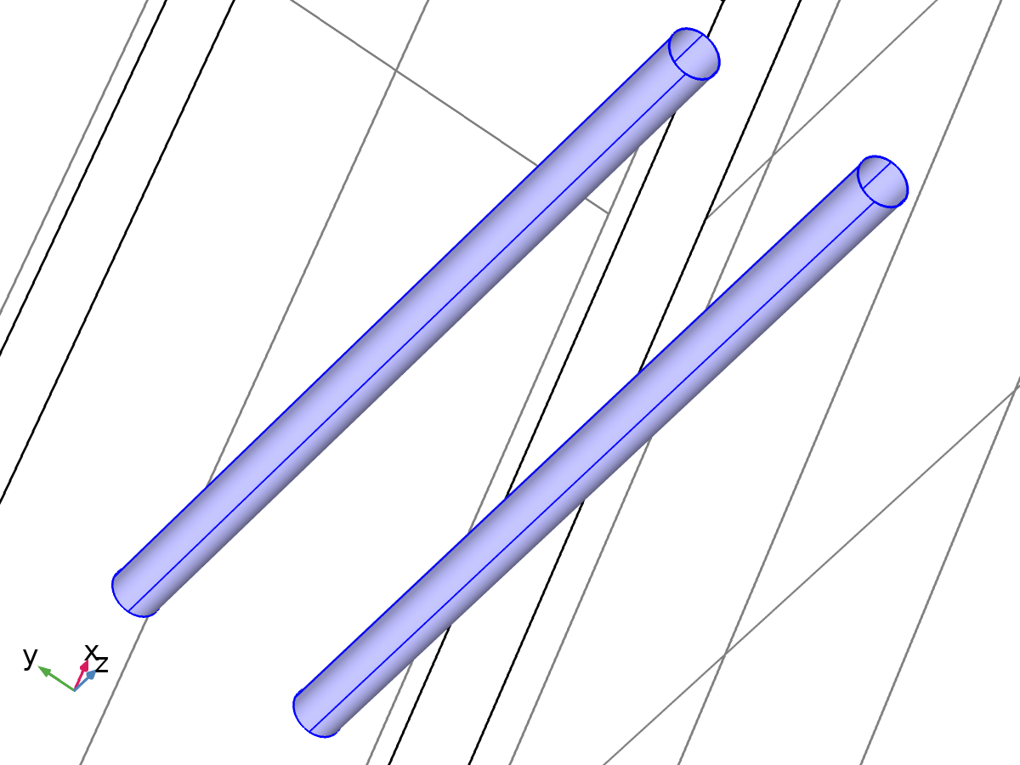

Wall 1

Selection

|  |  |
| --- | --- |
| Geometric entity level | Boundary |
| Selection | Boundaries 6–7, 10–11, 14–17 |

Equations



#### Boundary condition

Settings

| **Description** | **Value** |
| --- | --- |
| Wall condition | No slip |

#### Wall movement

Settings

| **Description** | **Value** |
| --- | --- |
| Translational velocity | Automatic from frame |
| Sliding wall | Off |

#### Variables

| **Name** | **Expression** | **Unit** | **Description** | **Selection** | **Details** |
| --- | --- | --- | --- | --- | --- |
| spf.ubndx | 0 | m/s | Velocity at boundary, x component | Boundaries 6–7, 10–11, 14–17 | + operation |
| spf.ubndy | 0 | m/s | Velocity at boundary, y component | Boundaries 6–7, 10–11, 14–17 | + operation |
| spf.ubndz | 0 | m/s | Velocity at boundary, z component | Boundaries 6–7, 10–11, 14–17 | + operation |
| spf.uLeakagex | 0 | m/s | Leakage velocity, x component | Boundaries 6–7, 10–11, 14–17 | + operation |
| spf.uLeakagey | 0 | m/s | Leakage velocity, y component | Boundaries 6–7, 10–11, 14–17 | + operation |
| spf.uLeakagez | 0 | m/s | Leakage velocity, z component | Boundaries 6–7, 10–11, 14–17 | + operation |
| spf.noSlipWall | 1 | 1 | Help variable | Boundaries 6–7, 10–11, 14–17 |  |

#### Constraints

| **Constraint** | **Constraint force** | **Shape function** | **Selection** | **Details** |
| --- | --- | --- | --- | --- |
| -u+spf.ubndx+spf.uLeakagex | test(-u) | Lagrange (Linear) | Boundaries 6–7, 10–11, 14–17 | Elemental |
| -v+spf.ubndy+spf.uLeakagey | test(-v) | Lagrange (Linear) | Boundaries 6–7, 10–11, 14–17 | Elemental |
| -w+spf.ubndz+spf.uLeakagez | test(-w) | Lagrange (Linear) | Boundaries 6–7, 10–11, 14–17 | Elemental |

* + 1. Inlet 1

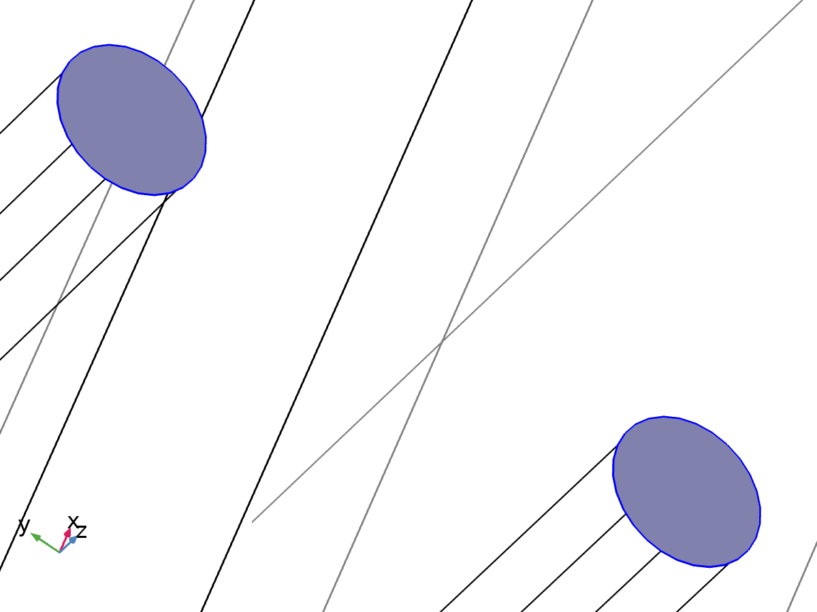

Inlet 1

Selection

|  |  |
| --- | --- |
| Geometric entity level | Boundary |
| Selection | Boundaries 9, 13 |

Equations



#### Boundary condition

Settings

| **Description** | **Value** |
| --- | --- |
| Boundary condition | Velocity |

#### Velocity

Settings

| **Description** | **Value** |
| --- | --- |
| Velocity field componentwise | Normal inflow velocity |
| Normal inflow velocity | 0.02 |

#### Variables

| **Name** | **Expression** | **Unit** | **Description** | **Selection** | **Details** |
| --- | --- | --- | --- | --- | --- |
| spf.ubndx | -nojac(spf.nxmesh)*spf.U0in | m/s | Velocity at boundary, x component | Boundaries 9, 13 | + operation |
| spf.ubndy | -nojac(spf.nymesh)*spf.U0in | m/s | Velocity at boundary, y component | Boundaries 9, 13 | + operation |
| spf.ubndz | -nojac(spf.nzmesh)*spf.U0in | m/s | Velocity at boundary, z component | Boundaries 9, 13 | + operation |
| spf.U0in | 0.02 | m/s | Normal inflow velocity | Boundaries 9, 13 |  |

#### Constraints

| **Constraint** | **Constraint force** | **Shape function** | **Selection** | **Details** |
| --- | --- | --- | --- | --- |
| -u+spf.ubndx | test(-u+spf.ubndx) | Lagrange (Linear) | Boundaries 9, 13 | Elemental |
| -v+spf.ubndy | test(-v+spf.ubndy) | Lagrange (Linear) | Boundaries 9, 13 | Elemental |
| -w+spf.ubndz | test(-w+spf.ubndz) | Lagrange (Linear) | Boundaries 9, 13 | Elemental |

* + 1. Outlet 1

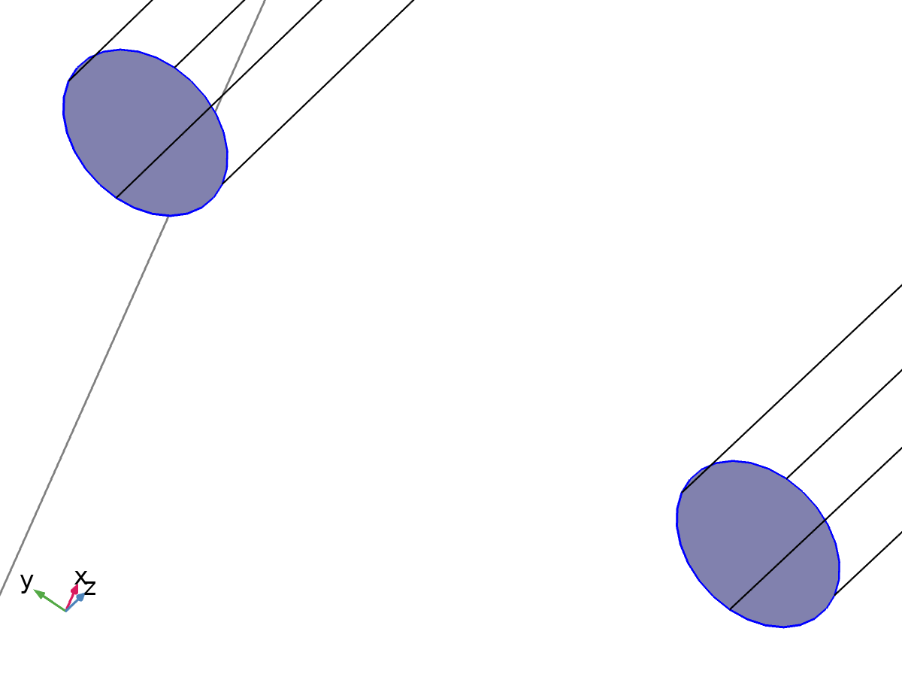

Outlet 1

Selection

|  |  |
| --- | --- |
| Geometric entity level | Boundary |
| Selection | Boundaries 8, 12 |

Equations





#### Boundary condition

Settings

| **Description** | **Value** |
| --- | --- |
| Boundary condition | Pressure |

#### Pressure conditions

Settings

| **Description** | **Value** |
| --- | --- |
| Pressure | 0 |
| Normal flow | Off |
| Suppress backflow | On |

#### Variables

| **Name** | **Expression** | **Unit** | **Description** | **Selection** |
| --- | --- | --- | --- | --- |
| spf.meshVol | meshvol_spatial | m² |  | Boundaries 8, 12 |
| spf.meshVolInt | up(meshvol_spatial) | m³ | Volume of interior mesh element | Boundaries 8, 12 |
| spf.c_here | 144/spf.epsilon_p | Pa·s/m | Intermediate variable | Boundaries 8, 12 |
| spf.rhoFace | up(spf.rho) | kg/m³ | Density face value | Boundaries 8, 12 |
| spf.umxTnFace | spf.upwind_helpx*spf.nxmesh+spf.upwind_helpy*spf.nymesh+spf.upwind_helpz*spf.nzmesh | m/s | Relative velocity on face | Boundaries 8, 12 |
| spf.upwind_ns | spf.backflowPenaltyConv*spf.uNormal | W/m² | Upwind term | Boundaries 8, 12 |
| spf.p0 | 0 | Pa | Pressure | Boundaries 8, 12 |
| spf.out1.Uav | 0 | m/s | Average velocity | Global |
| spf.out1.Uavfdf | 0 | m/s | Average velocity | Global |
| spf.out1.Mflow | spf.out1.intFlow(spf.rho*(spf.nx*u+spf.ny*v+spf.nz*w)) | kg/s | Mass flow | Global |
| spf.f0 | spf.p0+spf.uNormal*(spf.backflowPenaltyDiff-spf.backflowPenaltyConv)*(spf.uNormal<0) | N/m² | Normal stress | Boundaries 8, 12 |
| spf.uNormal | u*nojac(spf.nxmesh)+v*nojac(spf.nymesh)+w*nojac(spf.nzmesh) | m/s | Normal velocity | Boundaries 8, 12 |
| spf.backflowPenaltyDiff | spf.c_here*min((up(spf.mu)+spf.muT)*spf.meshVol/spf.meshVolInt,up(spf.rho)*abs(spf.uNormal)/up(spf.epsilon_p)) | kg²/(m⁴·s²) | Backflow penalty parameter, diffusive contribution | Boundaries 8, 12 |
| spf.backflowPenaltyConv | spf.rhoFace*spf.umxTnFace/spf.epsilon_p^2 | kg/(m²·s) | Backflow penalty parameter, convective contribution | Boundaries 8, 12 |

#### Weak expressions

| **Weak expression** | **Integration order** | **Integration frame** | **Selection** |
| --- | --- | --- | --- |
| -spf.f0*(test(u)*spf.nxmesh+test(v)*spf.nymesh+test(w)*spf.nzmesh) | 2 | Spatial | Boundaries 8, 12 |

* 1. Mesh 1

Mesh statistics

| **Description** | **Value** |
| --- | --- |
| Minimum element quality | 0.007651 |
| Average element quality | 0.5518 |
| Tetrahedron | 25546 |
| Pyramid | 64 |
| Prism | 10160 |
| Triangle | 6132 |
| Quad | 48 |
| Edge element | 772 |
| Vertex element | 24 |

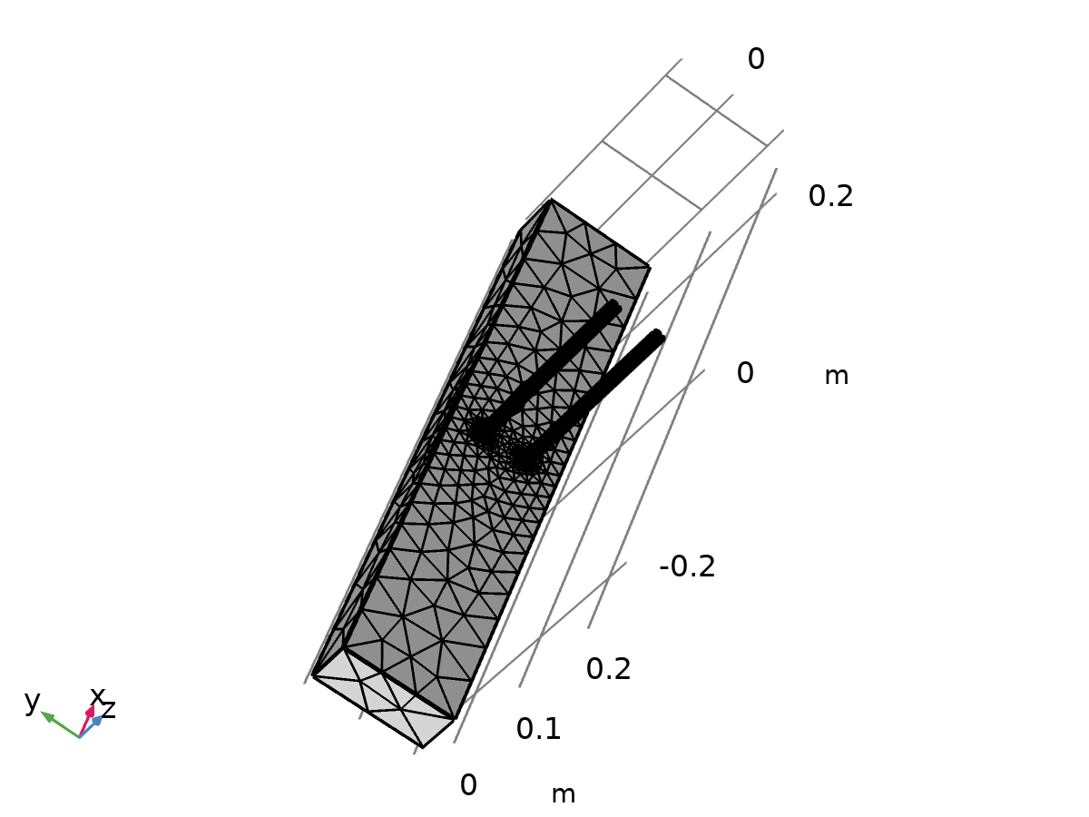

Mesh 1

* + 1. Size (size)

Settings

| **Description** | **Value** |
| --- | --- |
| Maximum element size | 0.05 |
| Minimum element size | 0.009 |
| Curvature factor | 0.6 |
| Resolution of narrow regions | 0.5 |
| Maximum element growth rate | 1.5 |

* + 1. Size 1 (size1)

Selection

|  |  |
| --- | --- |
| Geometric entity level | Domain |
| Selection | Domains 2–3 |

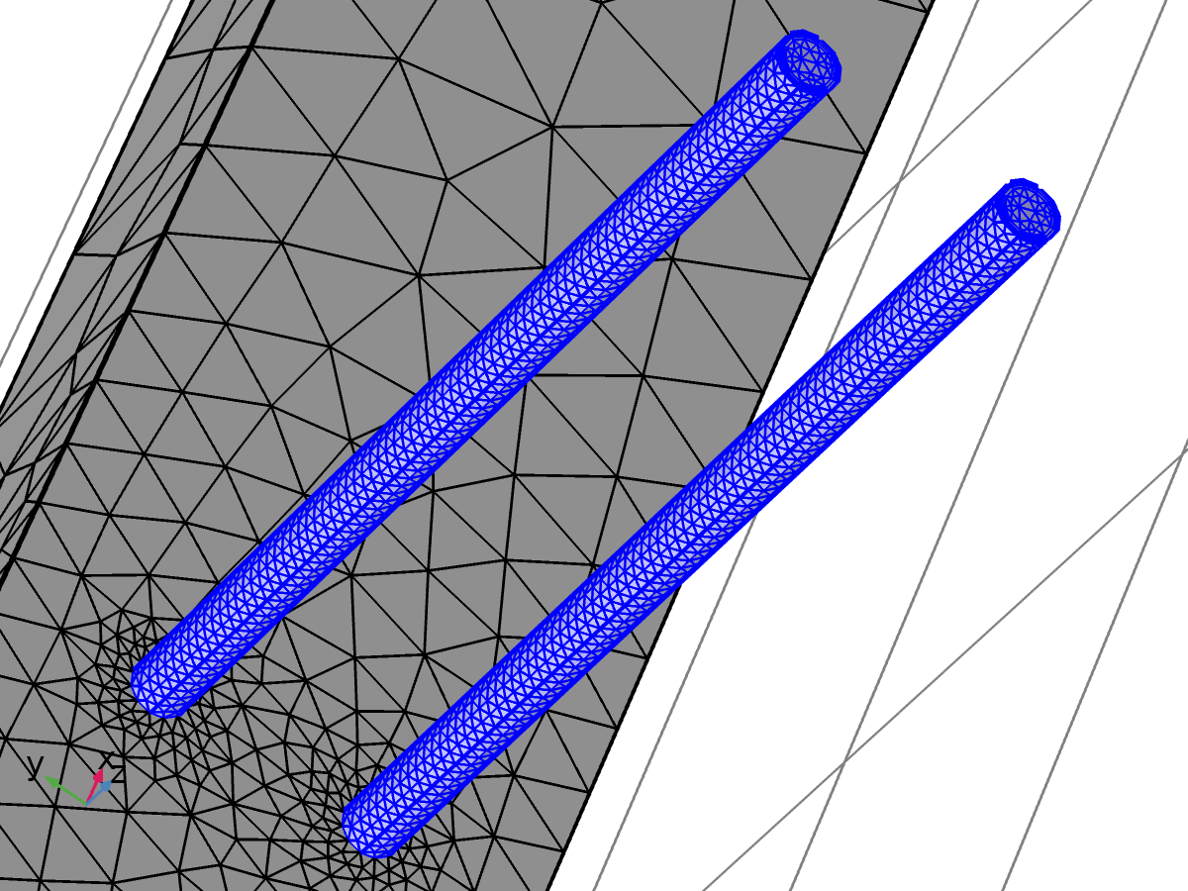

Size 1

Settings

| **Description** | **Value** |
| --- | --- |
| Calibrate for | Fluid dynamics |
| Maximum element size | 0.0158 |
| Minimum element size | 0.00474 |
| Curvature factor | 0.7 |
| Resolution of narrow regions | 0.6 |
| Maximum element growth rate | 1.2 |
| Predefined size | Coarse |

* + 1. Size 2 (size2)

Selection

|  |  |
| --- | --- |
| Geometric entity level | Boundary |
| Selection | Boundaries 6–7, 10–11, 14–17 |

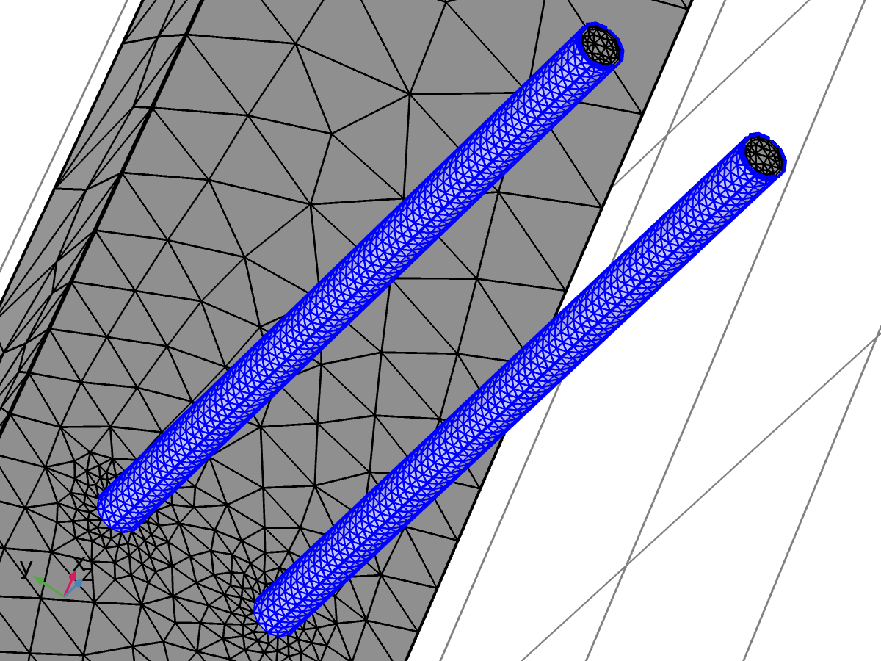

Size 2

Settings

| **Description** | **Value** |
| --- | --- |
| Calibrate for | Fluid dynamics |
| Maximum element size | 0.00838 |
| Minimum element size | 0.00158 |
| Curvature factor | 0.5 |
| Resolution of narrow regions | 0.8 |
| Maximum element growth rate | 1.13 |
| Predefined size | Fine |

* + 1. Corner Refinement 1 (cr1)

Selection

|  |  |
| --- | --- |
| Geometric entity level | Domain |
| Selection | Domains 2–3 |



Corner Refinement 1

* + 1. Free Tetrahedral 1 (ftet1)

Selection

|  |  |
| --- | --- |
| Geometric entity level | Remaining |



Free Tetrahedral 1

* + 1. Boundary Layers 1 (bl1)

Selection

|  |  |
| --- | --- |
| Geometric entity level | Domain |
| Selection | Domains 2–3 |



Boundary Layers 1

Settings

| **Description** | **Value** |
| --- | --- |
| Handling of sharp edges | Trimming |

#### Boundary Layer Properties 1 (blp1)

Selection

|  |  |
| --- | --- |
| Geometric entity level | Boundary |
| Selection | Boundaries 6–7, 10–11, 14–17 |



Boundary Layer Properties 1

Settings

| **Description** | **Value** |
| --- | --- |
| Number of boundary layers | 2 |
| Thickness adjustment factor | 5 |

1. Study 1

Computation information

|  |  |
| --- | --- |
| Computation time | 3 min 33 s |
| CPU | AMD64 Family 23 Model 96 Stepping 1, 6 cores |
| Operating system | Windows 10 |

* 1. Time Dependent

| **Times** | **Unit** |
| --- | --- |
| 0 300 | s |

Study settings

| **Description** | **Value** |
| --- | --- |
| Include geometric nonlinearity | Off |

Mesh selection

| **Geometry** | **Mesh** |
| --- | --- |
| mesh1 | mesh1 |

Physics and variables selection

| **Physics interface** | **Discretization** |
| --- | --- |
| Heat Transfer in Solids (ht) | physics |
| Laminar Flow (spf) | physics |

Mesh selection

| **Geometry** | **Mesh** |
| --- | --- |
| Geometry 1 (geom1) | mesh1 |

* 1. Stationary

Study settings

| **Description** | **Value** |
| --- | --- |
| Include geometric nonlinearity | Off |

Mesh selection

| **Geometry** | **Mesh** |
| --- | --- |
| mesh1 | mesh1 |

Physics and variables selection

| **Physics interface** | **Discretization** |
| --- | --- |
| Laminar Flow (spf) | physics |

Mesh selection

| **Geometry** | **Mesh** |
| --- | --- |
| Geometry 1 (geom1) | mesh1 |

* 1. Solver Configurations
     1. Solution 1

#### Compile Equations: Time Dependent (st1)

Study and step

| **Description** | **Value** |
| --- | --- |
| Use study | Study 1 |
| Use study step | Time Dependent |

Log

<---- Compile Equations: Time Dependent in Study 1/Solution 1 (sol1) -----------

Started at Apr 28, 2025 12:53:03 PM.

Geometry shape order: Linear

Running on AMD64 Family 23 Model 96 Stepping 1, AuthenticAMD.

Using 1 socket with 6 cores in total on Harshita.

Available memory: 7.63 GB.

Time: 3 s.

Physical memory: 1.57 GB

Virtual memory: 2.37 GB

Ended at Apr 28, 2025 12:53:05 PM.

----- Compile Equations: Time Dependent in Study 1/Solution 1 (sol1) ---------->

#### Dependent Variables 1 (v1)

General

| **Description** | **Value** |
| --- | --- |
| Defined by study step | Time Dependent |

Residual scaling

| **Description** | **Value** |
| --- | --- |
| Method | Manual |

Initial value calculation constants

| **Constant name** | **Initial value source** |
| --- | --- |
| t | 0 300 |
| timestep | 0.01[s] |

Log

<---- Dependent Variables 1 in Study 1/Solution 1 (sol1) -----------------------

Started at Apr 28, 2025 12:53:05 PM.

Solution time: 0 s.

Physical memory: 1.58 GB

Virtual memory: 2.37 GB

Ended at Apr 28, 2025 12:53:06 PM.

----- Dependent Variables 1 in Study 1/Solution 1 (sol1) ---------------------->

##### Pressure (comp1.p) (comp1_p)

General

| **Description** | **Value** |
| --- | --- |
| Field components | comp1.p |

##### Temperature (comp1.T) (comp1_T)

General

| **Description** | **Value** |
| --- | --- |
| Field components | comp1.T |

##### Velocity field (comp1.u) (comp1_u)

General

| **Description** | **Value** |
| --- | --- |
| Field components | {comp1.u, comp1.v, comp1.w} |

#### Time-Dependent Solver 1 (t1)

General

| **Description** | **Value** |
| --- | --- |
| Defined by study step | Time Dependent |
| Times | {0, 300} |
| Relative tolerance | 0.005 |

Absolute tolerance

| **Description** | **Value** |
| --- | --- |
| Tolerance factor | 0.05 |

Settings: Pressure (comp1.p)

| **Description** | **Value** |
| --- | --- |
| Method | Scaled |
| Tolerance factor | 1 |

Time stepping

| **Description** | **Value** |
| --- | --- |
| Initial step | 0.01 |
| Initial step | On |
| Maximum BDF order | 2 |
| Nonlinear controller | On |
| Fraction of initial step for Backward Euler | 0.01 |
| Error estimation | Exclude algebraic |

Log

<---- Time-Dependent Solver 1 in Study 1/Solution 1 (sol1) ---------------------

Started at Apr 28, 2025 12:53:06 PM.

Time-dependent solver (BDF)

Number of degrees of freedom solved for: 46540 (plus 37889 internal DOFs).

Symmetric matrices found.

Scales for dependent variables:

Temperature (comp1.T): 3.3e+02

Nonsymmetric matrix found.

Scales for dependent variables:

Pressure (comp1.p): 0.25

Velocity field (comp1.u): 1

Nonsymmetric matrix found.

Step        Time    Stepsize      Res  Jac  Sol Order Tfail NLfail   LinErr   LinRes

   0           0           - out   26    6   26                  0

                   Group #1:       13    3   13                       1e-15  2.6e-16

                   Group #2:       13    3   13                     8.5e-13  1.2e-14

   1  0.00015625  0.00015625       90   14   90     1     1      2

                   Group #1:       45    7   45                       1e-15  2.6e-16

                   Group #2:       45    7   45                     6.8e-13  2.9e-14

   2  0.00027512  0.00011887       96   16   96     1     1      2

                   Group #1:       48    8   48                     9.6e-16  2.4e-16

                   Group #2:       48    8   48                     3.5e-12  1.2e-14

   3  0.00028935  1.4226e-05      120   22  120     1     3      2

                   Group #1:       60   11   60                     9.7e-16  2.4e-16

                   Group #2:       60   11   60                       5e-13  2.4e-14

   4  0.00029715  7.7992e-06      136   26  136     1     4      2

                   Group #1:       68   13   68                     9.9e-16  2.5e-16

                   Group #2:       68   13   68                     2.9e-12  2.6e-14

   5  0.00030342  6.2762e-06      142   28  142     1     4      2

                   Group #1:       71   14   71                       1e-15  2.6e-16

                   Group #2:       71   14   71                     9.6e-13    4e-14

   6   0.0003097  6.2762e-06      150   30  150     1     4      2

                   Group #1:       75   15   75                       1e-15  2.6e-16

                   Group #2:       75   15   75                     7.9e-13  2.1e-14

   7  0.00031445  4.7539e-06      160   32  160     1     4      2

                   Group #1:       80   16   80                       1e-15  2.6e-16

                   Group #2:       80   16   80                     9.5e-13  9.4e-14

   8  0.00031921  4.7539e-06      168   34  168     1     4      2

                   Group #1:       84   17   84                       1e-15  2.6e-16

                   Group #2:       84   17   84                     1.4e-12  2.4e-14

   9  0.00032396  4.7539e-06      178   36  178     1     4      2

                   Group #1:       89   18   89                     1.1e-15  2.6e-16

                   Group #2:       89   18   89                     2.1e-12  7.1e-14

  10  0.00033347  9.5078e-06      188   38  188     1     4      2

                   Group #1:       94   19   94                     9.8e-16  2.5e-16

                   Group #2:       94   19   94                     7.7e-13  1.3e-14

  11  0.00034298  9.5078e-06      202   40  202     1     4      2

                   Group #1:      101   20  101                     9.2e-16  2.4e-16

                   Group #2:      101   20  101                       6e-13  8.4e-15

  12  0.00036199  1.9016e-05      216   42  216     1     4      2

                   Group #1:      108   21  108                     9.4e-16  2.5e-16

                   Group #2:      108   21  108                       8e-13  3.1e-15

  13  0.00040002  3.8031e-05      230   44  230     1     4      2

                   Group #1:      115   22  115                     9.8e-16  2.6e-16

                   Group #2:      115   22  115                     6.2e-13  5.2e-15

  14  0.00043805  3.8031e-05      242   46  242     1     4      2

                   Group #1:      121   23  121                     9.4e-16  2.5e-16

                   Group #2:      121   23  121                     5.1e-13  2.4e-15

  15  0.00051412  7.6062e-05      252   48  252     1     4      2

                   Group #1:      126   24  126                       1e-15  2.5e-16

                   Group #2:      126   24  126                     3.6e-13  2.4e-15

  16  0.00066624  0.00015212      260   50  260     1     4      2

                   Group #1:      130   25  130                     9.8e-16  2.5e-16

                   Group #2:      130   25  130                     1.5e-13    1e-15

  17  0.00081837  0.00015212      266   52  266     1     4      2

                   Group #1:      133   26  133                       1e-15  2.5e-16

                   Group #2:      133   26  133                     9.4e-13  1.8e-15

  18   0.0011226  0.00030425      274   54  274     1     4      2

                   Group #1:      137   27  137                     1.2e-15  2.5e-16

                   Group #2:      137   27  137                     1.2e-13  9.2e-16

  19   0.0014269  0.00030425      280   56  280     1     4      2

                   Group #1:      140   28  140                     1.1e-15  2.5e-16

                   Group #2:      140   28  140                     3.4e-13  2.7e-15

  20   0.0020354   0.0006085      288   58  288     1     4      2

                   Group #1:      144   29  144                     1.1e-15  2.5e-16

                   Group #2:      144   29  144                     3.7e-14  1.4e-15

  21   0.0032524    0.001217      296   60  296     1     4      2

                   Group #1:      148   30  148                     9.3e-16  2.5e-16

                   Group #2:      148   30  148                     8.9e-14  1.8e-14

  22   0.0044694    0.001217      302   62  302     1     4      2

                   Group #1:      151   31  151                       1e-15  2.7e-16

                   Group #2:      151   31  151                       2e-13  4.2e-15

  23   0.0069033    0.002434      310   64  310     1     4      2

                   Group #1:      155   32  155                     1.1e-15  2.4e-16

                   Group #2:      155   32  155                     2.5e-14    3e-15

  24   0.0093373    0.002434      316   66  316     1     4      2

                   Group #1:      158   33  158                     1.2e-15  2.4e-16

                   Group #2:      158   33  158                     2.5e-14  6.1e-15

  25    0.011771    0.002434      320   68  320     1     4      2

                   Group #1:      160   34  160                     1.1e-15  2.4e-16

                   Group #2:      160   34  160                     2.5e-14  4.6e-15

  26    0.016639    0.004868      328   70  328     1     4      2

                   Group #1:      164   35  164                     1.1e-15  2.3e-16

                   Group #2:      164   35  164                     1.4e-13  6.1e-15

  27    0.021507    0.004868      334   72  334     1     4      2

                   Group #1:      167   36  167                     1.1e-15  2.3e-16

                   Group #2:      167   36  167                     1.1e-13  1.3e-14

  28    0.026375    0.004868      338   74  338     1     4      2

                   Group #1:      169   37  169                     1.1e-15  2.3e-16

                   Group #2:      169   37  169                     1.1e-13  9.3e-15

  29    0.031243    0.004868      342   76  342     1     4      2

                   Group #1:      171   38  171                     1.2e-15  2.4e-16

                   Group #2:      171   38  171                     2.2e-13  8.2e-15

  30    0.040979    0.009736      348   78  348     1     4      2

                   Group #1:      174   39  174                     1.1e-15  2.8e-16

                   Group #2:      174   39  174                       3e-14  3.4e-14

  31    0.050715    0.009736      354   80  354     1     4      2

                   Group #1:      177   40  177                       1e-15  2.7e-16

                   Group #2:      177   40  177                     8.8e-14    4e-14

  32    0.060451    0.009736      358   82  358     1     4      2

                   Group #1:      179   41  179                       1e-15  2.7e-16

                   Group #2:      179   41  179                     1.4e-13  1.7e-14

  33    0.079923    0.019472      364   84  364     2     4      2

                   Group #1:      182   42  182                     9.6e-16  2.4e-16

                   Group #2:      182   42  182                     1.6e-13    8e-15

  34    0.099395    0.019472      370   86  370     2     4      2

                   Group #1:      185   43  185                     9.8e-16  2.4e-16

                   Group #2:      185   43  185                     5.2e-14  3.8e-14

  35     0.11887    0.019472      376   88  376     2     4      2

                   Group #1:      188   44  188                     9.7e-16  2.7e-16

                   Group #2:      188   44  188                     7.9e-14  5.5e-14

  36     0.13834    0.019472      380   90  380     2     4      2

                   Group #1:      190   45  190                     1.2e-15  2.6e-16

                   Group #2:      190   45  190                     1.8e-13    7e-14

  37     0.15781    0.019472      384   92  384     2     4      2

                   Group #1:      192   46  192                     1.1e-15  2.5e-16

                   Group #2:      192   46  192                       2e-13  2.8e-14

  38     0.19675    0.038944      388   94  388     2     4      2

                   Group #1:      194   47  194                       1e-15  2.4e-16

                   Group #2:      194   47  194                     5.6e-14  7.8e-15

  39      0.2357    0.038944      394   96  394     2     4      2

                   Group #1:      197   48  197                     1.1e-15  2.5e-16

                   Group #2:      197   48  197                     3.2e-14  3.5e-14

  40     0.27464    0.038944      398   98  398     2     4      2

                   Group #1:      199   49  199                     1.1e-15  2.4e-16

                   Group #2:      199   49  199                     1.2e-13  2.6e-14

  41     0.31359    0.038944      402  100  402     2     4      2

                   Group #1:      201   50  201                     1.1e-15  2.5e-16

                   Group #2:      201   50  201                       1e-13  2.3e-14

  42     0.35253    0.038944      406  102  406     2     4      2

                   Group #1:      203   51  203                     1.1e-15  2.4e-16

                   Group #2:      203   51  203                     8.4e-14  2.1e-14

  43     0.43042    0.077888      410  104  410     2     4      2

                   Group #1:      205   52  205                       1e-15  2.6e-16

                   Group #2:      205   52  205                       1e-13  1.5e-14

  44     0.50831    0.077888      416  106  416     2     4      2

                   Group #1:      208   53  208                       1e-15  2.5e-16

                   Group #2:      208   53  208                     7.5e-14  2.7e-14

  45     0.58619    0.077888      420  108  420     2     4      2

                   Group #1:      210   54  210                       9e-16    3e-16

                   Group #2:      210   54  210                     2.5e-14  5.3e-14

  46     0.66408    0.077888      424  110  424     2     4      2

                   Group #1:      212   55  212                     1.2e-15  2.6e-16

                   Group #2:      212   55  212                     1.3e-14  2.2e-14

  47     0.81986     0.15578      428  112  428     2     4      2

                   Group #1:      214   56  214                     1.1e-15  2.4e-16

                   Group #2:      214   56  214                       5e-14  7.7e-15

  48     0.97563     0.15578      434  114  434     2     4      2

                   Group #1:      217   57  217                     1.2e-15  2.4e-16

                   Group #2:      217   57  217                     9.2e-15  2.1e-14

  49      1.1314     0.15578      438  116  438     2     4      2

                   Group #1:      219   58  219                     1.2e-15  2.4e-16

                   Group #2:      219   58  219                     4.4e-14  2.7e-14

  50      1.2872     0.15578      442  118  442     2     4      2

                   Group #1:      221   59  221                     1.1e-15  2.4e-16

                   Group #2:      221   59  221                     6.3e-15  1.9e-14

  51       1.443     0.15578      446  120  446     2     4      2

                   Group #1:      223   60  223                     1.1e-15  2.5e-16

                   Group #2:      223   60  223                     6.3e-14  1.8e-14

  52      1.7545     0.31155      450  122  450     2     4      2

                   Group #1:      225   61  225                     8.6e-16  2.7e-16

                   Group #2:      225   61  225                     4.5e-14  6.5e-15

  53      2.0661     0.31155      454  124  454     2     4      2

                   Group #1:      227   62  227                     8.7e-16  2.7e-16

                   Group #2:      227   62  227                     1.1e-14    5e-14

  54      2.3776     0.31155      458  126  458     2     4      2

                   Group #1:      229   63  229                       1e-15  2.4e-16

                   Group #2:      229   63  229                     3.5e-14  2.5e-14

  55      2.6892     0.31155      462  128  462     2     4      2

                   Group #1:      231   64  231                       1e-15  2.4e-16

                   Group #2:      231   64  231                     2.5e-14    2e-14

  56      3.3123      0.6231      466  130  466     2     4      2

                   Group #1:      233   65  233                     7.7e-16  3.6e-16

                   Group #2:      233   65  233                     8.1e-15  2.2e-14

  57      3.9354      0.6231      470  132  470     2     4      2

                   Group #1:      235   66  235                     7.3e-16  3.4e-16

                   Group #2:      235   66  235                     2.5e-15  2.5e-14

  58      5.1816      1.2462      474  134  474     1     4      2

                   Group #1:      237   67  237                     8.5e-16  3.2e-16

                   Group #2:      237   67  237                     1.8e-14  2.9e-14

  59       7.674      2.4924      476  136  476     1     4      2

                   Group #1:      238   68  238                     7.6e-16  3.1e-16

                   Group #2:      238   68  238                     6.1e-15  4.3e-15

  60      12.659      4.9848      478  138  478     1     4      2

                   Group #1:      239   69  239                     8.4e-16  3.2e-16

                   Group #2:      239   69  239                     4.1e-15  3.8e-15

  61      22.628      9.9696      480  140  480     1     4      2

                   Group #1:      240   70  240                       7e-16  4.5e-16

                   Group #2:      240   70  240                     6.9e-15  1.7e-14

  62      42.568      19.939      482  142  482     1     4      2

                   Group #1:      241   71  241                       7e-16  4.6e-16

                   Group #2:      241   71  241                     2.5e-15  1.5e-14

  63      72.568          30      484  144  484     1     4      2

                   Group #1:      242   72  242                     7.3e-16  4.7e-16

                   Group #2:      242   72  242                     8.1e-15  1.7e-14

  64      102.57          30      486  146  486     1     4      2

                   Group #1:      243   73  243                     8.6e-16    5e-16

                   Group #2:      243   73  243                     2.5e-15  2.4e-14

  65      132.57          30      488  148  488     1     4      2

                   Group #1:      244   74  244                     8.8e-16  5.3e-16

                   Group #2:      244   74  244                     5.8e-15  1.5e-14

  66      162.57          30      490  150  490     1     4      2

                   Group #1:      245   75  245                     8.2e-16  5.1e-16

                   Group #2:      245   75  245                     1.7e-14  6.4e-15

  67      192.57          30      492  152  492     1     4      2

                   Group #1:      246   76  246                     8.4e-16  5.4e-16

                   Group #2:      246   76  246                       4e-15  1.1e-14

  68      222.57          30      494  154  494     1     4      2

                   Group #1:      247   77  247                     8.5e-16    5e-16

                   Group #2:      247   77  247                     9.7e-16  1.2e-14

  69      252.57          30      496  156  496     1     4      2

                   Group #1:      248   78  248                     8.2e-16  5.3e-16

                   Group #2:      248   78  248                       4e-15  5.3e-15

  70      282.57          30      498  158  498     1     4      2

                   Group #1:      249   79  249                     8.3e-16  4.9e-16

                   Group #2:      249   79  249                     2.1e-14  4.3e-15

   -         300           - out

  71      312.57          30      500  160  500     1     4      2

                   Group #1:      250   80  250                     8.7e-16    5e-16

                   Group #2:      250   80  250                     2.1e-14  3.7e-15

Time-stepping completed.

Solution time: 209 s. (3 minutes, 29 seconds)

Physical memory: 2.18 GB

Virtual memory: 2.99 GB

Ended at Apr 28, 2025 12:56:36 PM.

----- Time-Dependent Solver 1 in Study 1/Solution 1 (sol1) -------------------->

##### Advanced (aDef)

Assembly settings

| **Description** | **Value** |
| --- | --- |
| Reuse sparsity pattern | On |

##### Segregated 1 (se1)

General

| **Description** | **Value** |
| --- | --- |
| Tolerance factor | 0.5 |
| Stabilization and acceleration | Anderson acceleration |
| Dimension of iteration space | 5 |
| Mixing parameter | 0.9 |
| Iteration delay | 1 |

###### Heat transfer T (ss1)

General

| **Description** | **Value** |
| --- | --- |
| Variables | Temperature (comp1.T) |
| Linear solver | PARDISO (ht) |

Method and termination

| **Description** | **Value** |
| --- | --- |
| Damping factor | 0.8 |
| Jacobian update | Once per time step |

###### Velocity u, Pressure p (ss2)

General

| **Description** | **Value** |
| --- | --- |
| Variables | {Velocity field (comp1.u), Pressure (comp1.p)} |
| Linear solver | Direct 2 |

Method and termination

| **Description** | **Value** |
| --- | --- |
| Damping factor | 0.9 |
| Jacobian update | Once per time step |

###### Lower Limit 1 (ll1)

Lower limit

| **Description** | **Value** |
| --- | --- |
| Lower limits (field variables) | comp1.T 0 |

##### PARDISO (ht) (d1)

General

| **Description** | **Value** |
| --- | --- |
| Solver | PARDISO |
| Pivoting perturbation | 1.0E-13 |

##### Direct 2 (d2)

General

| **Description** | **Value** |
| --- | --- |
| Solver | PARDISO |
| Pivoting perturbation | 1.0E-13 |

1. Results
   1. Data Sets
      1. Study 1/Solution 1

Solution

| **Description** | **Value** |
| --- | --- |
| Solution | Solution 1 |
| Component | Save Point Geometry 1 |

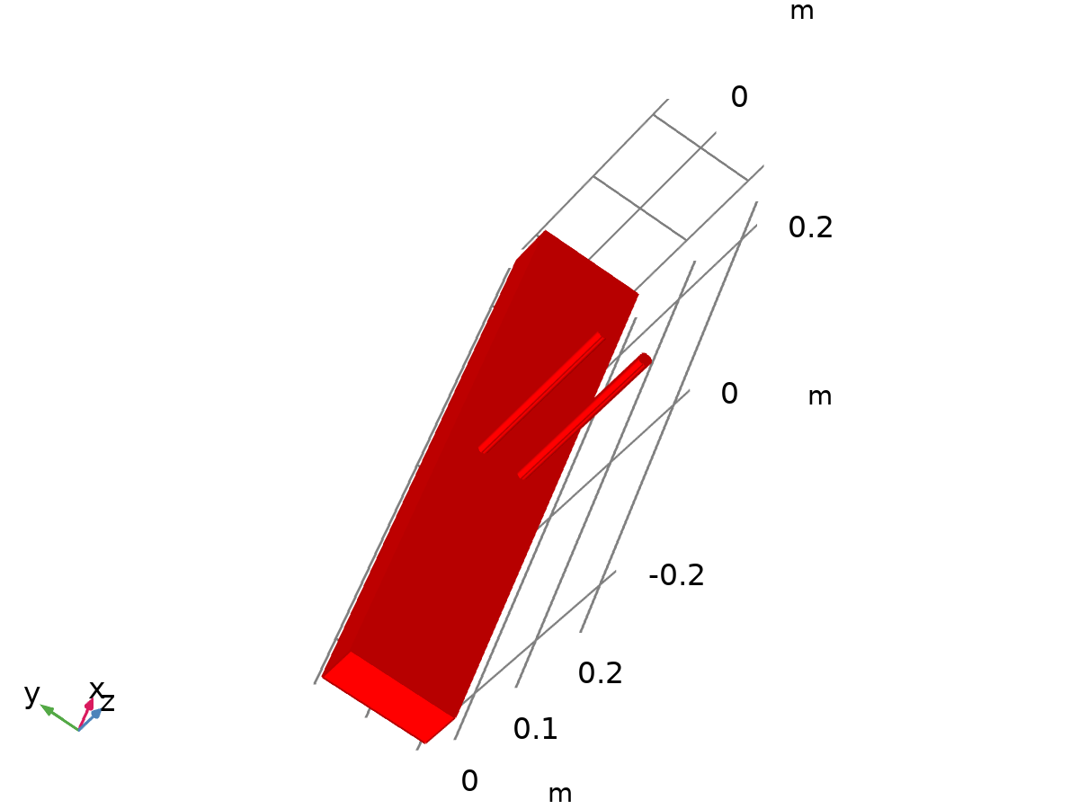

Data set: Study 1/Solution 1

* + 1. Exterior Walls

Data

| **Description** | **Value** |
| --- | --- |
| Data set | Study 1/Solution 1 |

Parameterization

| **Description** | **Value** |
| --- | --- |
| x- and y-axes | Surface parameters |

* 1. Derived Values
     1. Surface Integration 1

Output

|  |  |
| --- | --- |
| Evaluated in | Table 1 |

Data

| **Description** | **Value** |
| --- | --- |
| Data set | Study 1/Solution 1 |

Expressions

| **Expression** | **Unit** | **Description** |
| --- | --- | --- |
| ht.nteflux | W | Normal total energy flux |

Integration settings

| **Description** | **Value** |
| --- | --- |
| Integration order | 4 |

* 1. Tables
     1. Table 1

Surface Integration 1 (-ht.nteflux)

| **Time (s)** | **-ht.nteflux (W)** | **-ht.nteflux (W)** | **-ht.nteflux (W)** | **-ht.nteflux (W)** | **-ht.nteflux (W)** | **-ht.nteflux (W)** | **-ht.nteflux (W)** |
| --- | --- | --- | --- | --- | --- | --- | --- |
| 0.0000 | 1.9251E-11 | 1.9251E-11 | 1.9251E-11 | 1.9251E-11 | 1.9251E-11 | 1.9251E-11 | 1.9251E-11 |
| 300.00 | -1.6319E-15 | -1.6319E-15 | -1.6319E-15 | -1.6319E-15 | -1.6319E-15 | -4.0091E-16 | -5.7456E-16 |

* 1. Plot Groups
     1. Temperature (ht)

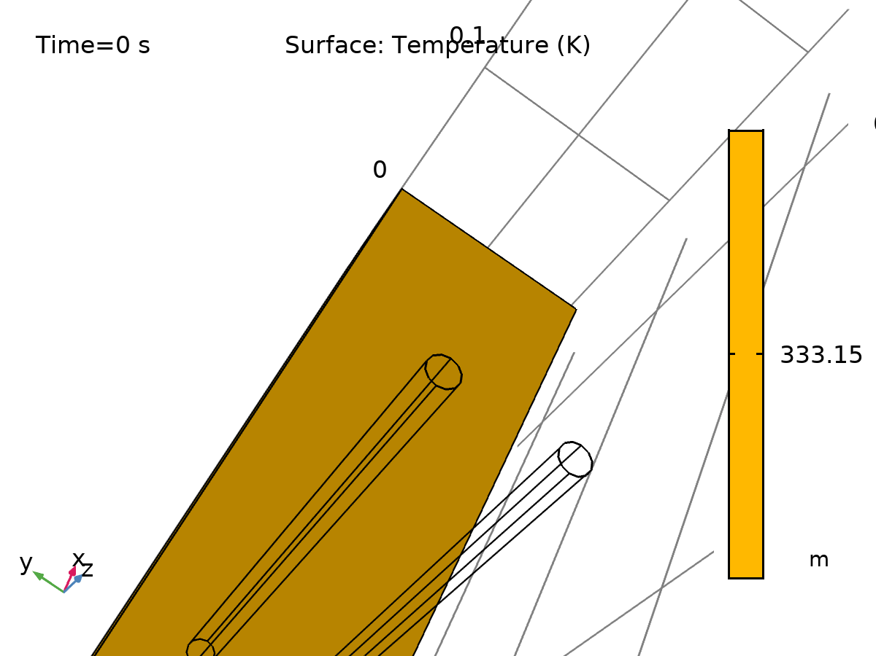

Surface: Temperature (K)

* + 1. Isothermal Contours (ht)

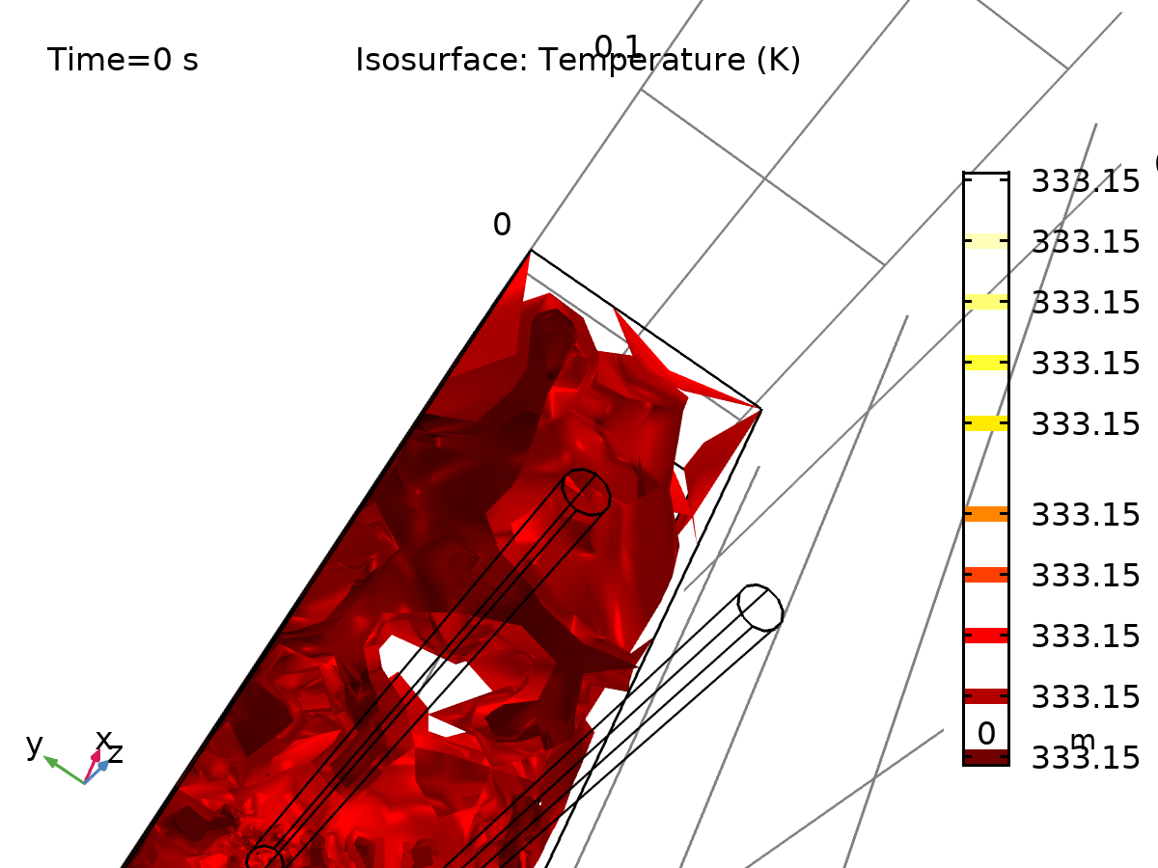

Isosurface: Temperature (K)

* + 1. Velocity (spf)

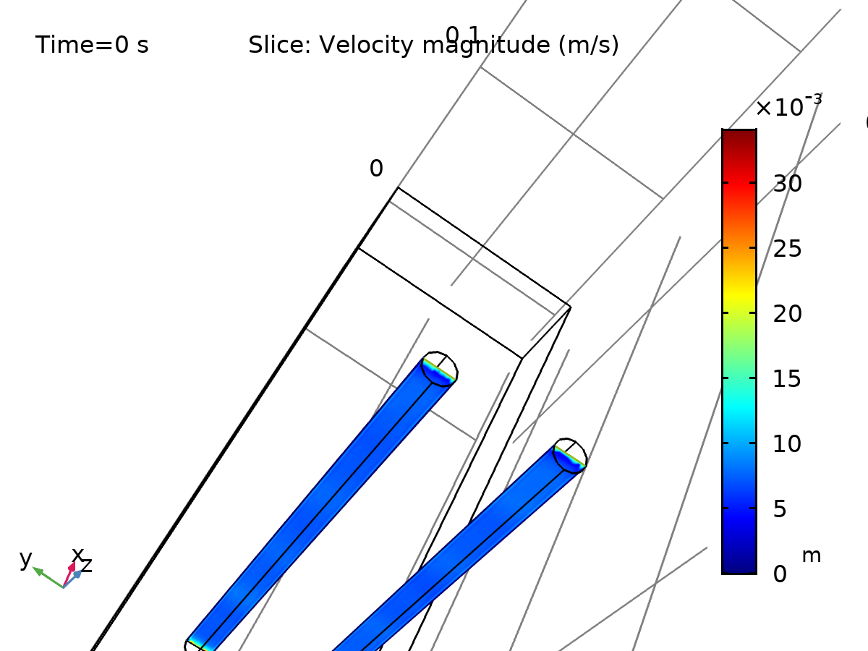

Slice: Velocity magnitude (m/s)

* + 1. Pressure (spf)

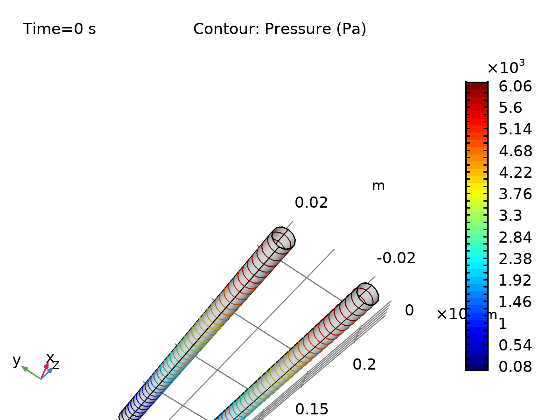

Contour: Pressure (Pa)

* + 1. 1D Plot Group 5

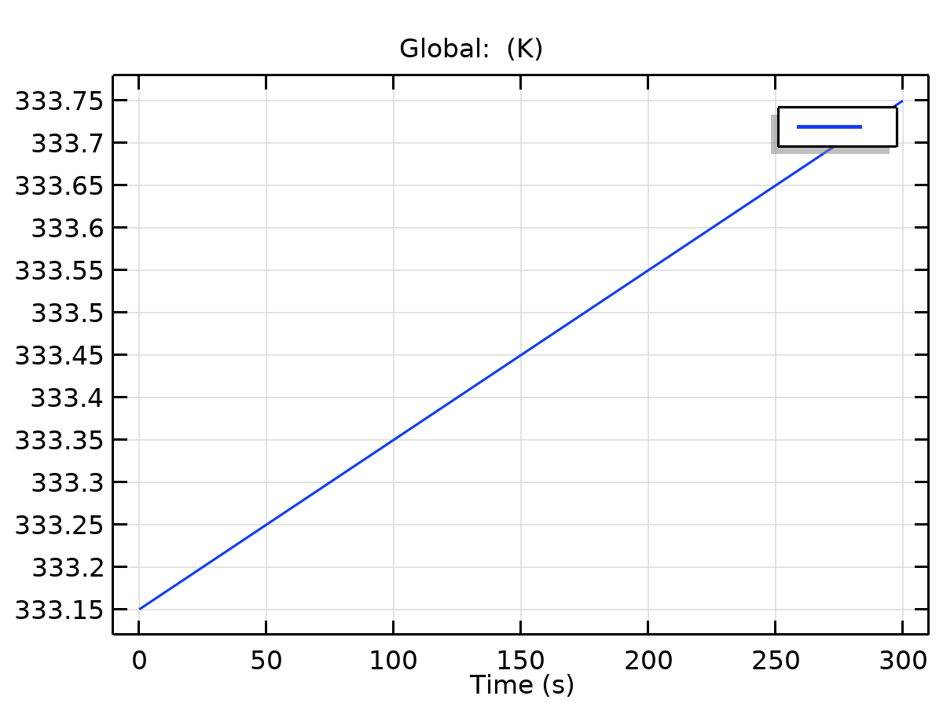

Global: (K)

* + 1. 1D Plot Group 6

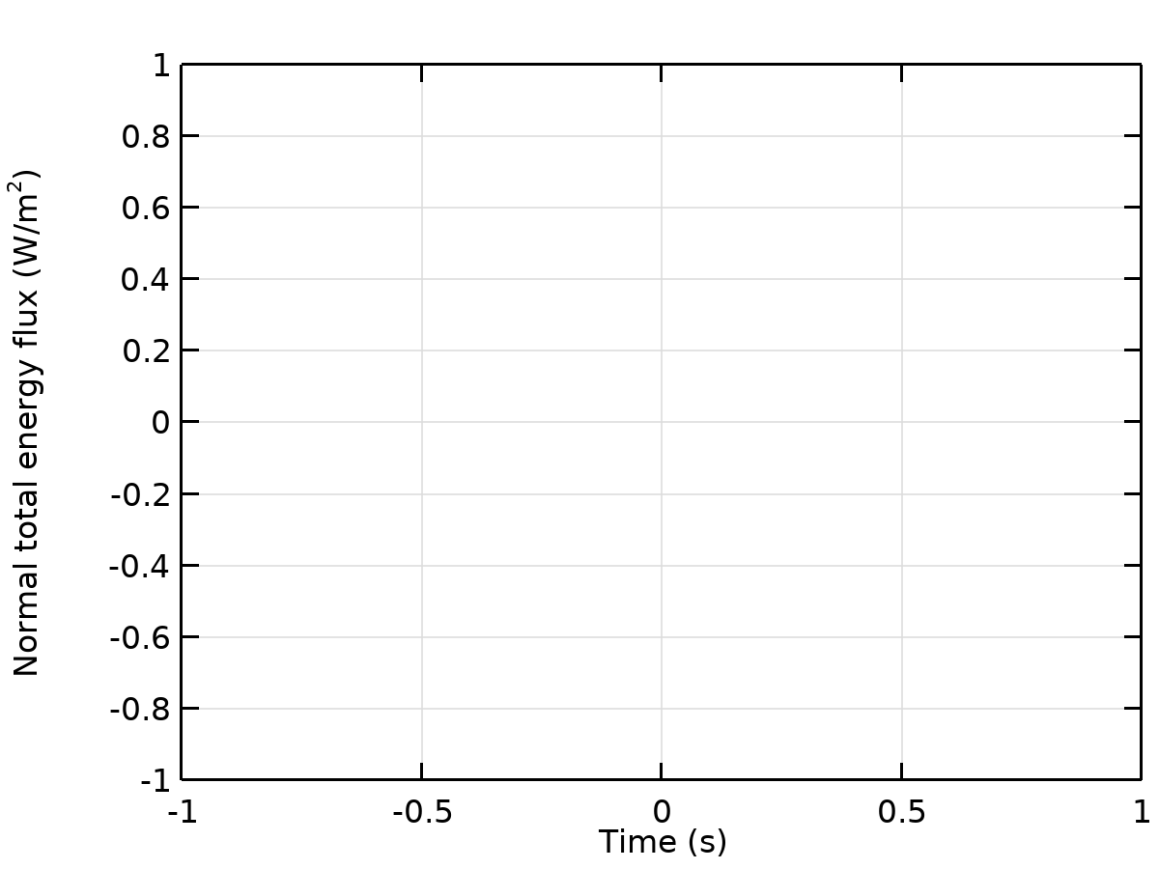

Global: Normal total energy flux (W/m2)